Welcome back
We would like to welcome back all of our students for what is looking like a very exciting term 4. We have lots going on this term, and we have already hit the ground running. We hope all of our families had a happy and safe break; it was great to see everyone’s smiling faces on Monday.
You may have noticed the new security system in place. When you come to the school, you will notice a doorbell; when this is rung, the door can be released from Sylvia’s office or someone can come. Thanks to the P&C for supporting this additional safety device- keeping our kids safe.

Special Swimming Scheme
Purple Class and Blue Class will be participating in the Special Swimming Scheme for the next two weeks. This will require the school bus and our extra swimming staff to make it safe and successful. Please be aware that if your child is not in Purple or Blue Class that there will be no swimming for two weeks.

School Camp
School Camp is only a few weeks away. I am still waiting for a few people to complete online registration as Berry Sport and Recreation Staff need the information as soon as possible. If you have not yet completed the online registration please do so today. I will be following up with phone calls tomorrow.

AAC Survey
We are seeking parents who have been asked to use an AAC system with their child who is aged 0-8 years. It does not matter if you are still using the AAC system or not. We would like to ask anyone who is interested to complete a 30 - 45 minute online questionnaire about your child and family. You can save and exit the survey and return at any time.
AAC stands for augmentative and alternative communication, and includes things like:
· Sign language
· Symbol books or boards (e.g., PODD)
· Speech generating devices
· Picture Exchange Communication Systems (PECS)
· iPad apps for communication (e.g., Proloquo2Go).
All participants will go into the draw to receive a $50 Coles-Myer gift card.
This research is expected to help speech pathologists understand the perspectives of families, so that they can more effectively support the communication development of children with disabilities. If you would like to take part, please go to the following website to complete the survey. https://survey.app.uq.edu.au/AAC-Survey.aspx

Special Olympics - Come and Try
This is not a program that will be run through the school however there may be some families that wish to take up this great opportunity. If you would like an entry form please contact the school and we can send one home.
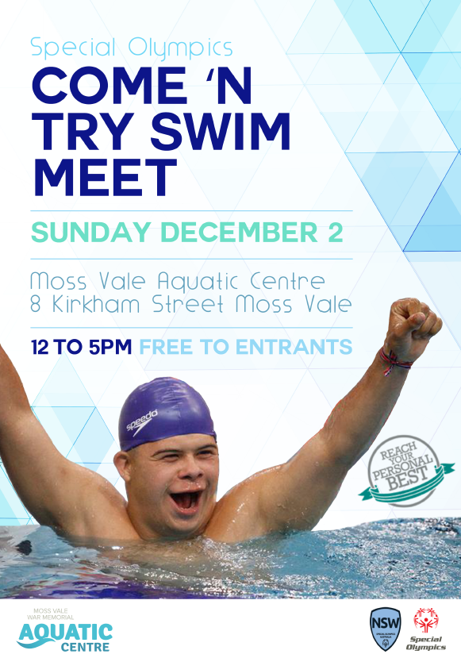

School Reports Semester 2
Towards the end of term, our semester 2 reports will be going out. If you could please return the folder that went out with your child’s report in semester 1, that would be wonderful.
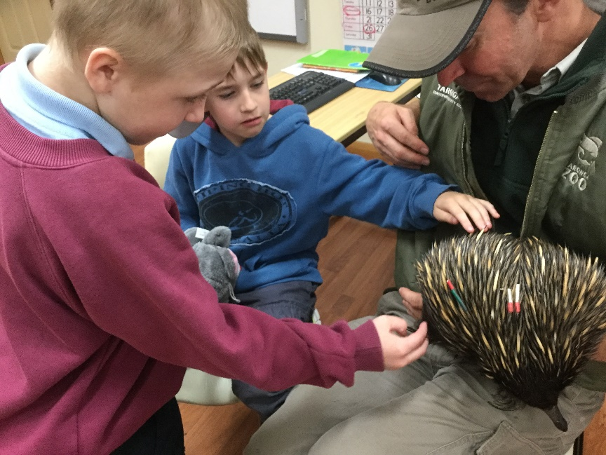

Zoo Visit
At the end of Term 3 we had the Zoo Mobile visit our school. They bought in lots of different animals for the students to have a look at like this beautiful echidna, snakes, lizards even a stick spider. All of our students here at Budawang enjoyed the visit immensely and everyone loved having pats and cuddles with all the animals. Thank you to Taronga Zoo and the Zoo Mobile for making this possible for our students here at Budawang.
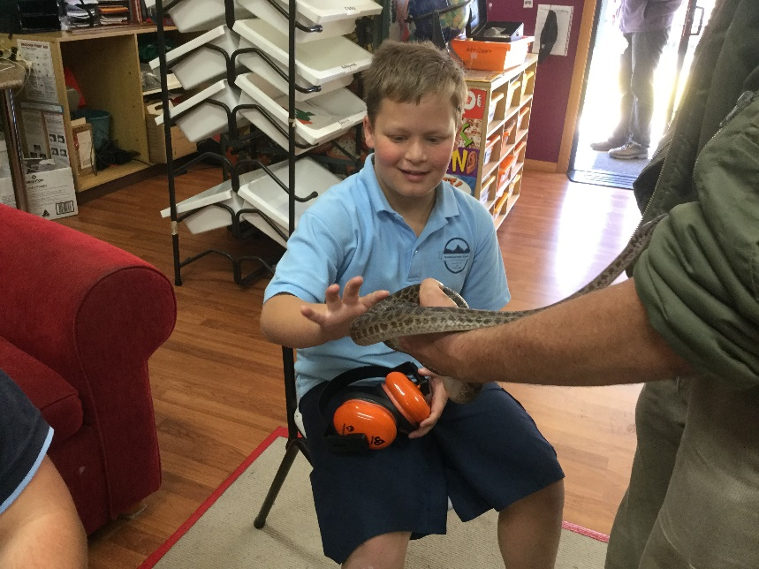

Student Awards
Blue Class
Tommy – For using his manners and saying “no thank you”
Purple Class
Phoenix – For a great start to Term 4 and doing so well at getting back into routine.
Yellow Class
Daniel – For having a great attitude towards his work this week.
Green Class
Rocky – Welcome back Rocky after being away unwell.
Red Class
Jada – For having a calm, cooperative start to the term.
Calendar
15th October | Students back to school.
22 Oct – 2 Nov | Special Swimming Scheme
23 October | P&C meeting 1:30pm
24 October | AECG meeting inc AGM @6:30pm
8-9 Nov | School Camp
10 Dec | School Presentation Day
12 Dec | Year 12 Graduation
19th Dec | Last day of school for 2018
20th & 21st December | The last two days of Term 4 are listed as Staff Development/Pupil Free days. Our staff are undertaking extra training throughout Term 3, equivalent to these two days. Therefore the school will be closed on 20th - 21st December.

Sheryl’s Retirement.
As you all may know, Sheryl officially confirmed her retirement last term. I would like to acknowledge the wonderful contribution that Sheryl made both at the school, and in the community, for students with disability.
I will keep the community informed about the process for identifying her permanent replacement.

