Fun in the main playground
Learning to play with each other is a skill that requires explicit teaching and modelling for our students at Budawang school. Playing with others requires the ability to interact with others and communicate with others positively. Choosing a game to play, turn taking, sharing, waiting your turn, developing an interest in a game, learning the rules coping with upset if the game does not go to plan- these are all aspects that come into play when playing with others. Budawang teachers explicitly model to students how to develop and understand these concepts during class time and when on duty in the playground. The playground can be quite a busy and sensory over loading time for our students and teachers are very aware of this. On the playground students have been playing with sensory items including bubbles, shaving cream and playdough- many students have shown a great interest in these. Teachers also use this playtime as a chance to encourage students to play in imaginary games of schools, workout/fitness time, soldiers, different animal movements and being a mechanic in a garage.

Playing a fun game of soldiers on the playground

Being helpful in Purple Class
3pm arrived and it was time to go home. Khy was making his way towards his bag to place on his back and SLSO Shannon was assisting him. Olivia was also walking out of Purple room to gather her bag and could see and also hear Shannon saying to Khy “Time to put your bag on”. Olivia calmly picked up Khys bag and helped him to put his arm through the strap and then onto his back. This was such a kind and helpful act Olivia- Thankyou for being a beautiful helpful friend.

Thankyou for helping your friend Olivia

Soon we will be farewelling Karen
Karen has been acting Principal at Budawang for 2018 and the first Semester 2019. Staff, students and families have welcomed her warmly and were keen to discover who she was and what attributes she was to bring to Budawang. Coming from Havenlee SSP as the Assistant Principal she had leadership experience to bring, teaching expertise and knowledge to share particularly about programming, policies, safety and procedures. During her time at Budawang she has participated in our dress up days, led the school assembly, had fun at the Easter hat Parade, experienced a Budawang School presentation day and has guided and lead Budawang school during her time as Principal. Sadly, Karen’s time as Acting Principal ceases at the end of Term 2, 2019. Staff and students would like to thank Karen for the effort she has given during her time as Acting Principal and wish her all the best in her future.
Acting Principal- Karen

Do it for Dolly Day
Do it for Dolly Day is an initiative which hopes to extend the Dolly’s dream message with the community and build on the support available for those impacted by bullying. We want to raise awareness about the issue of bullying, provide support and deliver educational resources for parents whose children may be bullied or are bullying. On the 12 June we would like everyone to dress up in something Blue and bring a gold coin donation to raise funds for Do it for Dolly Day!
Lachlan and Rocky dressed up at our last fundraiser day which raised funds for Farmers.

New Principal to begin Term 3
Budawang school will be welcoming Kathryn Lang as our new Principal. Kathryn will commence her duties as Principal the beginning of Term 3 2019. Prior to her stepping up to the role officially in Term 3 she will visit Budawang School. During her visits students will have the opportunity to ask her questions about her interests and Kathryn to ask students about their likes and questions about themselves. Keep your eyes on future newsletters as it will contain more information about Katherine and when she will be visiting.

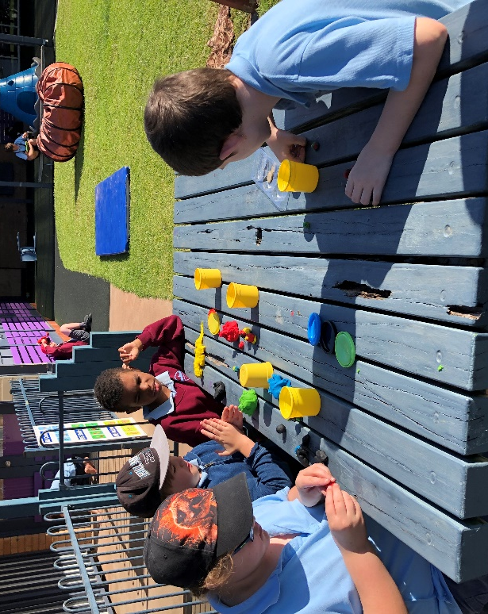
Students playing with playdough during playtime on the playground

School start and finish times
A reminder to all of our families and for our new families that the opening time for school is 8:55am and finish time is 3:00pm. Lessons begin at 9:25. There may be staff at school in the morning and afternoons but our staff use this time to have meetings, prepare lessons, activities, classrooms and visual supports for the students in their class. As such, there is no teacher or learning support officer rostered on duty until 8:55am. Please keep this in mind at drop off and pick up times. We appreciate your efforts to stick to the following times.

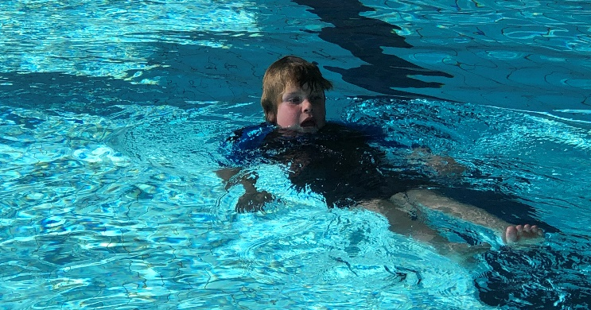
Dylan participating in his most favourite activity- swimming
Please use the change in season to make sure that all clothes, lunchboxes and bottles are clearly labelled with student names.

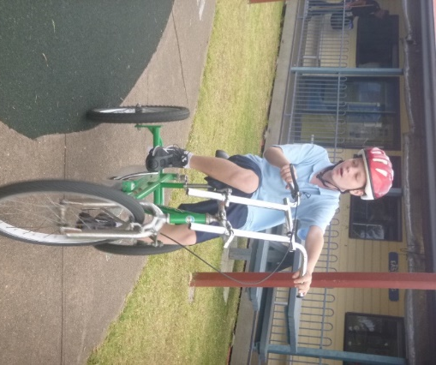

Ryan bike riding

Student Awards
Blue Class
Thomas – For trying very hard to keep his hands to himself.
Mia – For making new friends at Ulladulla Public School.
Purple Class
Phoenix – For trying hard to write letters independently.
Luca – For working hard on his independent writing.
Yellow
Noah – For great behaviour and enjoyment with mum at the pool.
Ashton – For fantastic desk work.
Green Class
Michael – For his patience and happy face making us laugh every day.
Flynn – For his fantastic cutting skills in cooking.
Red Class
Lachlan – For sharing great news every day this week and for fabulous guitar playing while wearing his sheriffs hat.
Liam – For his excellent communication and interaction using the eye gaze with his class.
RFF Col Award
Tye – For fantastic bike riding skills.
Lachlan – For his fabulous flipper skills in the pool with Red Class swimming.
Calendar
3 June | P&C Meeting 1:30pm school library
12 June | Do it for Dolly Day
W10 term 2  First week July | NAIDOC week @ Budawang
1 August | P&C Meeting 1:30 school library.
12-13 August | Senior Berry Camp
14 September | One day fun day

COMMUNITY NEWS
The following articles have been submitted for inclusion in our newsletter and are not part of Budawang SSP School curriculum:

One day fun day
One day fun day is a national event that provides a free fun day for disadvantaged, sick or at risk children and their carers across Australia. This day encourages children to get off their devices, get active and into nature. One day fun day is a day to remember 10,000 Australian kids and carers across our country. You can register with One Day Fun Day and express your interest in an experience. Please contact Fun Search directly if you are interested in becoming involved.
www.funsearch.com.au
maria@funsearch.com.au
hello@funsearch.com.au
0419584348
Fun Search are also on Instagram and Facebook.

Adult Education
Adult English and Literacy Classes at St Martins Anglican Church, corner of Green Street and Princes Highway Ulladulla. Contact 4454 2030 or 0414822788 or just turn up. Help will be given if English is your second language or if you have trouble with reading and writing.

