NAIDOC Mural – Red Class
In the lead up to NAIDOC Week celebrations, Red Class students have had the wonderful experience and opportunity of collaborating with a group of Indigenous Aboriginal students from Ulladulla High School in creating an Aboriginal Mural in the sensory playground. A beautiful scene of Uluru will be the finished art piece, it will be completed Thursday 4th July during Budawang school NAIDOC week celebrations. Budawang students and Ulladulla High School students are painting the mural on the fence in the sensory garden. Working together to design and create a beautiful mural with the High school students builds a greater understanding of the meaning behind the NAIDOC theme this year: Voice. Treaty. Truth. Let’s work together for a shared future. Budawang will be celebrating NAIDOC week during Week 10, Term 2 where an assembly and the completion of the mural will be occurring on Thursday 4th July.

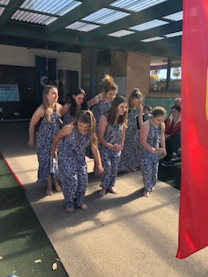
Ulladulla High school students performing a beautiful Indigenous dance last year at our NAIDOC week celebrations.

Yoga- positive vibes
As reported, at the beginning of the term, Green class students have had the opportunity of participating in a Yoga session once a week this term. The Yoga sessions have been kindly conducted by Judi, who has volunteered her time to do this with the students. Green class students have learnt basic necessary skills and moves required to perform Yoga, one move which students particularly enjoyed was the hunter using his/her bow and arrow. Thankyou Judi!

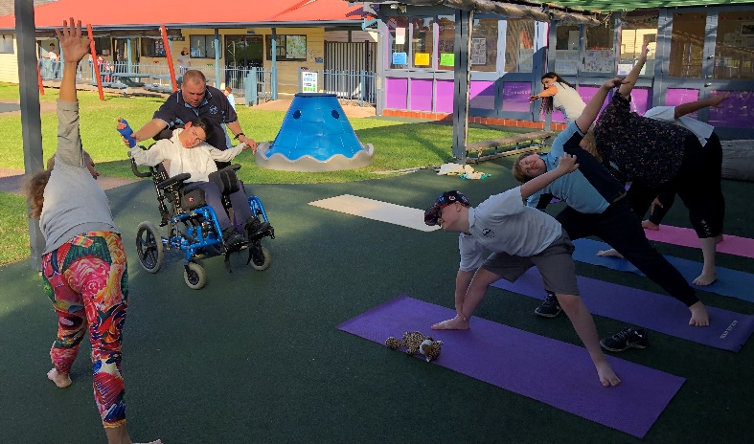
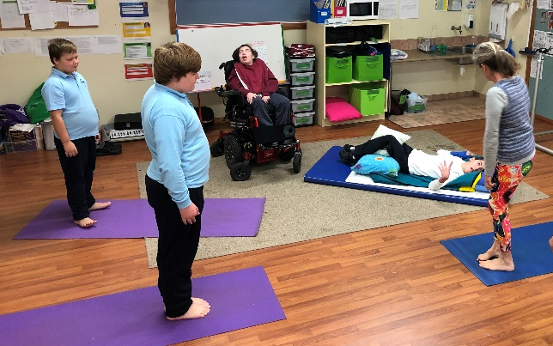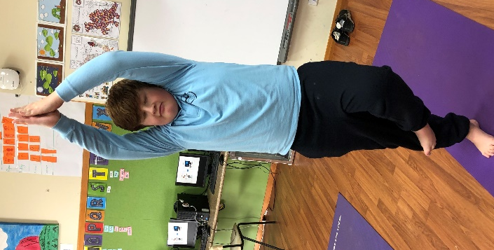

Help maintain wellness by keeping your sick child at home.
We have lots of coughs and colds about during the winter months. We would like to stress the importance of keeping your child at home when they are sick. This not only helps with minimising the spread of infection but also helps your child rest while they recover. Schools are very busy places and can be over-whelming and over stimulating for sick children. In a setting like Budawang where the children are still learning about personal hygiene our students and staff are more easily exposed to the cough and cold germs carried by sick children. Our staff and students cannot work effectively when they are sick so we appreciate your assistance in helping to keep everyone at Budawang School well. Students were sent home with a note at the beginning of this week informing families that there have been students diagnosed with influenza B. If your child is sick for the benefit of everyone, especially our vulnerable students, we thank you for keeping your child at home.

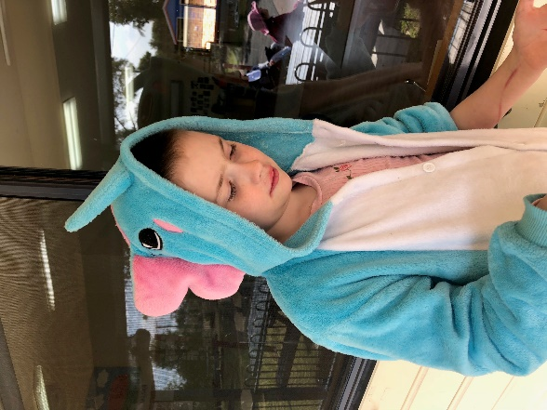
SLSO Shannon playing a game of fishing with Phoenix

Mid-Year Reports
Semester 1 reports will be handed out Friday 5th July. Each student’s report is a written record of each individual student’s progress towards achieving individual outcomes. Early Term 3, teachers will be having a meeting with parents to review and discuss their child’s LASP and determine if adjustments need to be made to fit the needs and goals for their child for the second semester.

School Holidays just around the corner
With the school holidays just around the corner, we would like to wish our families a happy and safe break. There are lots of fun activities around our wonderful community. Lots of bush walks including the local Aboriginal walks around Ulladulla. There is also Mount Bushwalker and even Pigeon House Mountain if you are game. The Mollymook Park “Livvi’s Place” is always a good place for our students to visit and have a laugh and maybe make new friends. We are very lucky to live in such a beautiful place with a wonderful community. Even though it is winter, we are still able to make the most of the cold weather and get out and about and active.
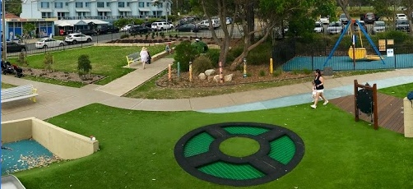
Snap shot of some of the play ground area at “Livvi’s place” playground in Mollymook

Super Hero Dress Up Day
On Wednesday 31st July, Week 2 Term 3, students and staff are encouraged to dress up as their favourite superhero to raise money for Muscular Dystrophy Australias’ programs, services and research. Don your best superhero costume, warm up your super powers and bring a gold coin donation to school to be a superhero for Muscular Dystrophy as part of National Superhero Week 2019. Budawang staff and students always enjoy a great reason to dress up!
Student Olivia at one of our dress up days last year.
STEM Share Program
The STEM Share Program assists teachers to educating students about Science, Technology, Engineering and Mathematics (STEM). Schools are able to hire out various kits to teach students specific aspects related to these topics. Budawang school has just recently been delivered the Tablet Robotic Kit which contains iPads, Dash Robots, LEGO WeDO and Blue-Bots. Some students have already explored the kit which is designed for students to engage with computational thinking and STEM concepts through tablet technology. All students in the school will have the opportunity to explore the use of the kit in their class. The kit is on hire to the school for one term before it moves to another school.

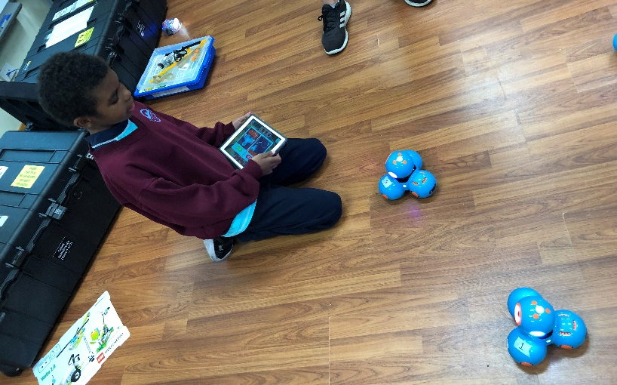
Lashawn exploring the use of the Dash Robots

Student Awards
Blue Class
Frankie Minato – for choosing his own drink bottle independently.
Purple Class
Olivia Knudsen-Newcombe – For doing a great job of moving to the music.
Yellow Class
Tye Fellows – For sharing the swing with his friends.
Green Class
Genevieve Hoek – For her beautiful manners in Green Class and Budawang School.
Red Class
Chris Yule – For being a good friend to peers when they were upset.

RFF
Phoenix Carriage – For asking a friend if they needed help and then proceeded to help the friend in need. .
Calendar
Monday 1st July | NAIDOC week @ Budawang  P&C meeting 1:30 Library: meet Kathryn, the new Principal
4th July | NAIDOC assembly: 11:00
5th July | Last day for Term 2
23rd July | First day back for Term 3
31st July | Super Hero Dress up day- gold coin donation
3rd Aug | P&C Library @ 1:30
12-13 August | Senior Berry Camp
14 September | One day fun day

Last Word
As this will be my last newsletter for Budawang School, I would like to take the opportunity to thank the community of Budawang for their welcome and support.
In my 18 months here, I have got to know every family and have thoroughly enjoyed working with you and your children to support their learning. My goal is always to encourage students to learn the skills that will enable them to be active contributors to the society and community in which they live.
I have also been awed by the wonderful army of volunteers who support us daily in their own free time and the generosity of the Ulladulla community.
To the wonderful staff, thanks for your patience and willingness to try new things and consider new ideas. It has been a pleasure to work with you all for the benefit of our students.
Finally to the students; I have loved every interaction- yes really. I have learnt more from you than I have imparted and wish you all well in your continuing schooling.

