NDIS Activities
If there are any parents or carers interested in different activities or after school care or respite, NDIS now have a brochure for winter with activities available. If you are interested, please let us know and we will be able to give you an enrolment form to fill out and a list of what is available.

New Principal Kathryn answers some questions asked by the students
Last week Kathryn Lang, Budawang’s newly appointed Principal who is officially starting her role in Term 3 visited Budawang for the first time. Students had prepared some questions for her to answer. Thankyou Lachlan, Archie, Flynn and Gen. This is what Kathryn had to say:
1) My favourite Super hero. That is a hard one. I have had to think about it!
Lachlan, I think it is Spider-Man!
2) Archie, my favourite food is anything Italian especially authentic, home-made pasta and Bruschetta.
3) Flynn, I like to cook a traditional Sunday Roast! Lamb and Pork are my favourite!
4) Gen, I visited London back in 2006 for only 2 days! I got to see Big Ben, London Bridge and Buckingham Palace! I remember it well because it was very hot and people were sitting in the fountain at Trafalgar Square! It was 40 degrees.

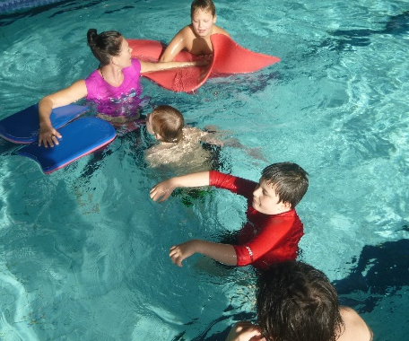
This year’s swimming and athletics carnivals will be fun for students, staff and families.
Swimming and Athletics carnival
Teachers are busy organising arrangements for the Budawang swimming and athletics carnival. Dates are to be set and announced soon. Parents and volunteers will be asked to assist on the day. If you are keen and available to help out for either carnival organisers will be very happy to assign you a task. Notes will be sent home to gain an indication from parents on their availability.

Do it for Dolly Day
On Wednesday 12 June 2019 we had “Do it for Dolly Day”. Dolly’s dream was to spread kindness and educating and empowering communities to prevent bullying. We asked all of our staff and students to dress in Blue and bring a gold coin donation. Dolly’s dream will act as a voice for those who cannot speak for themselves and create change by raising awareness about the serious effects of bullying, working to address bullying and cyber bullying issues and changing culture to help prevent bullying from happening. During class time students read books about being kind and participated in various activities regarding being kind. Almost all of our school was in Blue for Dolly, thank you to all of our students and families for dressing in Blue, the gold coin donation and getting involved. Students raised more than $30.

Lenny and Liam’s birthday
What a big day it was on Wednesday 12th June. Not only was it “Do it for Dolly Day”, but Liam celebrated his 17th birthday and Liam’s teacher, Lenny also celebrated her birthday. It was a double birthday in Red class with lots of fun had by the Birthday boy and girl. We would like to thank Liam’s Mum and Dad, Annette and Hao for putting on an amazing birthday party at school and for
buying Pizza for not only Red Class but for the whole school!
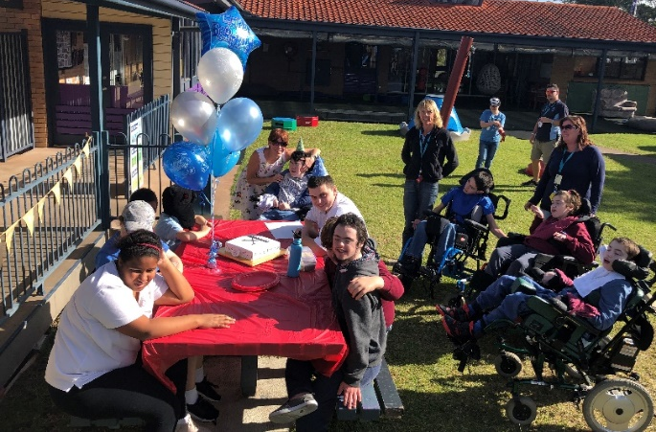
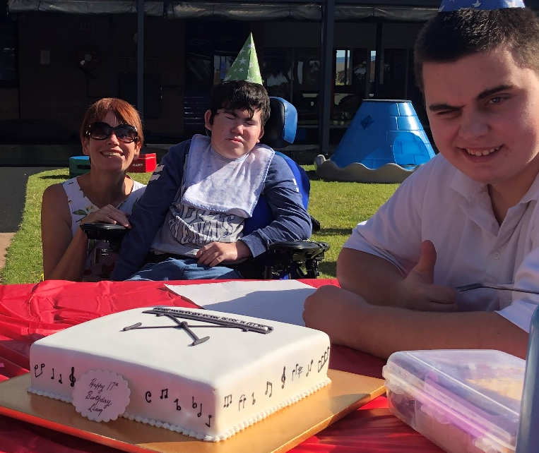
Birthday boy Liam with his Mum and friend Jarrah

School Camp Preparation
School Camp fun will be happening on the 12th and 13th August at Berry Sport and Recreation Centre (Term 3, Week 4). This is a senior camp organised for the older students. Permission notes will be sent home shortly. As per last year parents will need to log their child’s details via a web site. You will be informed of these log in details as soon as they become available.
Rock climbing at camp last year and marshmallows around the fire = fun!.

NAIDOC week
Each year NAIDOC Week celebrations are held across Australia to celebrate the history, culture and achievements of Aboriginal and Torres Strait Islander peoples. NAIDOC is celebrated not only in Indigenous communities, but by Australians from all walks of life.
Joke of the week
What do you call cheese that’s not yours?
Nacho cheese
Told by Chris- Red Class

NAIDOC originally stood for ‘National Aborigines and Islanders Day Observance Committee’. This committee was once responsible for organising national activities during NAIDOC Week and its acronym has since become the name of the week itself. Each year there is a theme for NAIDOC week, the 2019 theme is: Voice. Treaty. Truth. Let’s Work Together.
On Thursday 4th July (Week 10, Term 2) students from Ulladulla High School will be attending Budawang School to jointly create with Budawang students, an Indigenous Aboriginal art mural in the school. Students from the high school will perform music with didgeridoos and also perform a dance during the assembly to celebrate NAIDOC week.
Students from Ulladulla High performing at the Budawang school NAIDOC assembly 2018.

Red Class- Dreamtime
This term Red class have been focussing on the theme of Dreamtime. They have been reading stories, including the story “The rainbow serpent” and have been creating beautiful artwork. Students Dreamtime inspired artwork is displayed in their classroom and students from other classes are able to see the wonderful rainbow serpent art piece on the Red Class door from the main playground. Red class teacher, Lenny, has stated that all students have shown interest in the theme of Dreamtime.

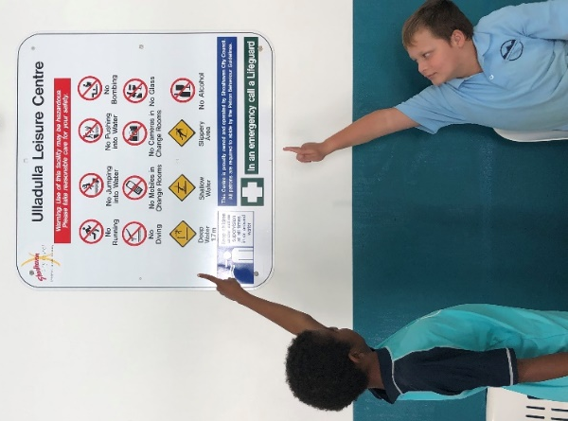
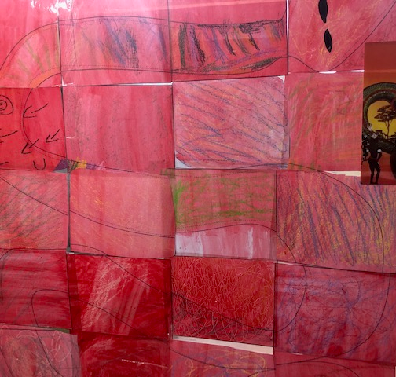
Red class created a rainbow serpent art piece after reading the story. It is beautifully displayed on the classroom door. Below is some other wonderful Dreamtime inspired art work.
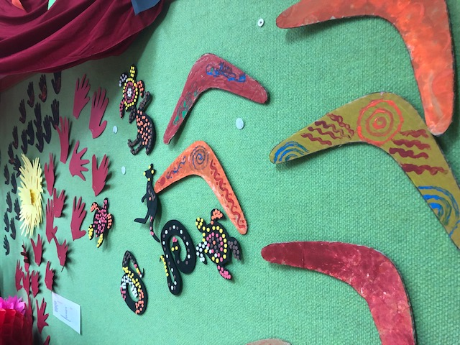

Green Class- Signs in the Community
Green class have been learning about signage and rules in the community. During their visit to the pool student’s attention has been brought to signs in the pool area and what they mean. Some students read the written rule and other students have been able to decipher what the rule is stating by the visual prompt picture. One rule states “No running”, students have been asked if you are not to run, then what do you think you are expected to do and why? They responded with “Walk, because it is slippery and you could slip and hurt yourself”. It is important to state what behaviour you expect of someone. Green class noticed that the rules were stated as to what they were not to do, so they were set the task of identifying what they should do.
Lashawn and Daniel pointing out the specific rules on the sign at the pool.

Student Awards
Blue Class
Nate – For sitting down at the table to eat his lunch.
Ava – For trying very hard to use pictures in the room to communicate.
Purple Class
Khy – For trying to be a kind friend.
Riley – For getting ready for class promptly.
Yellow
Zen – For fantastic independent skills in literacy and numeracy.
Declan – For fantastic participation and communication in Yellow Class.
Green Class
Angela – For her precise egg cracking and whisking the egg skills for the omelette in fried rice.
Daniel – For following instructions and staying with the group.
Red Class
Jarrah – For being brave during his operation. Red Class miss you.
Rocky – Welcome back to Red Class after being away last week.
RFF
Ryan – For excellent maths work on the smart board.
Zahra – For staying on task to create great artwork.
Calendar
W10 term 2  Monday 1st July | NAIDOC week @ Budawang P&C meeting 1:30 Library: meet Kathryn, the new Principal
4th July | NAIDOC assembly: 11:00
5th July | Last day for Term 2
23 July | First day back for Term 3
12-13 August | Senior Berry Camp
14 September | One day fun day

