Easter Hat Parade
We had our Easter Hat Parade on Friday 12 April. We would like to thank our Budawang families for attending. The weather was perfect and the students had a wonderful morning showing off their fantastic hats. It was a great morning followed by a fantastic barbeque cooked by Blue Class! We would like to thank Milton IGA for the deal of the century providing us with some delicious sausages and all that went with it. Kelly, Lizzy and Blue Class for setting up the day with the help of Alex and Steve. Also a big thank you to Sue, Ava’s mum for the donation of the Easter Eggs for each and every one of our students. A great way to end the term.
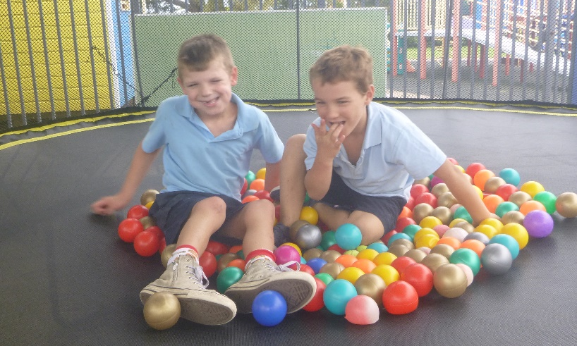
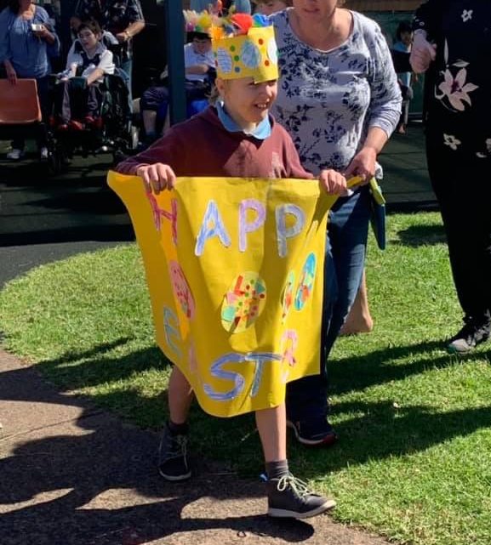

Term 2
We hope all of our families and friends had a nice break and a lovely Easter. It is great to be back at school for another term. At the end of last term in the newsletter we mentioned that there will be changes this term with staffing, so to jog your memory, we will be saying, “see you soon” to Elaine who is taking the rest of the year off to travel with her family. She will return at the beginning of next year to resume her Teaching and Assistant Principal Duties. Steve is also leaving us this year for retirement, he will be coming back for some casual work when he is not travelling, so you will still get to see his smiling face around the school every now and then. We are welcoming back Penny who will be Yellow Class teacher for the rest of the year. Simone and Lenny will be sharing the role of Assistant Principal for the rest of the year. We are excited to see what Term 2 has to offer and already this week, we have had a fantastic start and have hit the ground running.

Canteen-Lunch Orders
The Green Class have done a fantastic job cooking for the Thursday canteen last term. The fried rice has been enjoyed by many students and teachers and the word ‘delicious’ does not do it justice. Next Term Green Class will continue with the lunch orders on Thursdays and a note will come home early in Term 2, Green Class will continue to cook Fried Rice. Wednesdays are also a lunch order day. Students can order from the Ulladulla Public School Canteen. Please make sure that when you are doing a Wednesday Lunch Order that your child’s name and school are clearly printed on the lunch bag.

Expression of interest for Assisted Travel Support Officer (ATSO) position
The Assisted School Travel Program (ASTP) often provides additional support to students with disabilities on transport. Assisted Travel Support Officers (ATSOs) support students with complex health or behaviour needs to ensure their safe travel to and from school. If you are interested in temporary part-time work as an ATSO the following website contains information on how to apply for the position.
https://education.nsw.gov.au/public-schools/astp/atsos
For further information please contact ASTP on 1300 338 278 or email ASTP at atso.astp@det.nsw.edu.au
AST will pay for the training and the time to do it and we are particularly looking for people from the Bay and Basin area.

Purple Day Champions
Budawang School raised $75 for Epilepsy Action Australia on Purple Day in Term 1. For a small school with 35 students, this was a great amount. Thank you to all who donated for this worthy cause.

Dream Cricket
Look out Don Bradman, Budawang senior class students will be making ‘jaffas’, performing ‘lollys’ and calling ‘Howzat?’ at the upcoming Dream Cricket day. Senior classes have the exciting opportunity to participate in this fun event which is being held at Milton Public School on Tuesday 14th May. Permission notes have been sent home and many have been returned to school already. Budawang students have been involved in this activity in the past and it has proven to be a really fun and enjoyable day.

Green Class Yoga
Deep breathing, sun salutation movements and humming sounds? During Term 2 the lovely Yoga instructor Judi will be volunteering her time to run a Yoga session with Green Class students on a Tuesday afternoon. Benefits from yoga include the following: physically, it enhances flexibility, strength, coordination, and body awareness. In addition, concentration and a sense of calmness and relaxation have been reported. If students are able to take away from these yoga sessions at least one strategy to assist them in dealing with stress and anxiety they will have one extra self-regulatory strategy to utilise.

Adopt a Farmer
The Adopt a Farmer campaign aims to raise $800,000 through gold coin mufti days at NSW Public schools on Wed 8 May, with all proceeds going to farmers. The mufti day funds will be collected by registered charity, Rural Aid, which has so far distributed more than $10 million worth of fodder to farmers through the Buy a Bale campaign. p

Thank You
A big thank you to Kellams Bus Co who have donated the use of one of their buses while we are sorting out some admin issues with ours. This will mean that some of our programs will be restricted but most will continue due to Kellam’s generosity.

Student Awards

Blue Class
Ava – For leading the way in the following routines in Blue Class.
Purple Class
Riley – For making fantastic strides in Bike Riding.
Yellow
Kohen – For great communication in Yellow Class.
Green Class
Daniel – for great listening skills and participation in class.
Red Class
Shaylee – For excellent independent work in our super spelling Monday session.

.
Calendar
6 May | P&C AGM 1:30pm school library
8 May | Adopt a Farmer mufti day- gold coin donation
14 May | Dream Cricket MPS
15 May | AECG Meeting at Budawang; 6:00 for a light super then meeting.
3 June | P&C Meeting 1:30pm school library
W10 term 2 | NAIDOC week @ Budawang

