Dream Cricket
On Tuesday the 14th May Green and Red class students ventured to Milton Public School to participate in Dream Cricket. The day was a huge success where our students learnt some cricket skills and drills and had the wonderful opportunity of engaging and interacting with students from the support unit at Milton Public School. DreamCricket was initiated by Dr Roly Bigg of the Movement Disorder Foundation in concert with the Rotary Clubs of the Southern Highlands and the Bradman Foundation. The aim was to provide primary school students with special needs an opportunity to play cricket activities on Bradman Oval. The DreamCricket program has grown to encompass schools and children throughout Australia and internationally. Thankyou to Lenny for organising this sporting opportunity for our students.
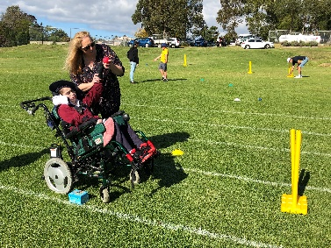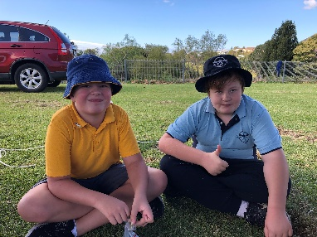
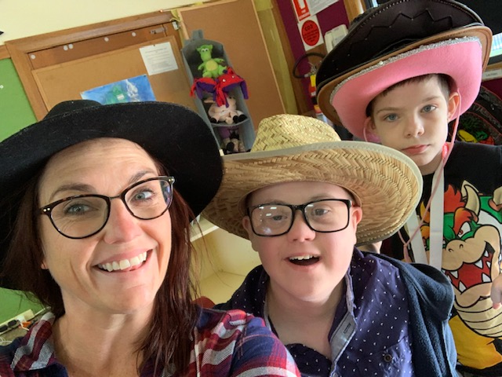
Pre Loved School Uniforms
We have lots of pre loved school uniforms available in various sizes, so if anyone is needing some winter uniforms with the cold weather ahead of us, please see Sylvia, Rach or Jenny to see what is available.

Mother’s day raffle winners
Congratulations to Deb, Simone, Jenny, Christine and Cheryl. We hope you enjoyed your lovely gifts from our raffle. Thank you again to Bliss Homewares in Milton, Thel Cross and Christine Ava’s nan for the donation of gifts.

St George Illawarra Dragons visit Budawang
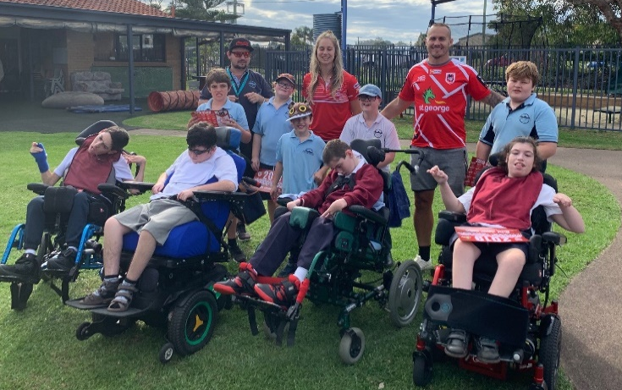
On Thursday the 2nd May, we had Matt Cooper and Kezie Apps come and visit Budawang School. Kezie is a current member of the St George Illawarra Dragons in the NRLW and Matt is an Australian for professional rugby league. He is a footballer who played his entire career with the Dragons and played in the NSW State of Origin. All of the students were very excited to see the guys and have a chat. Students also went home with a signed poster. Thank you Matt and Kezie for coming to our school and making our students day!

Adopt a Farmer
We raised a wicked $70 for the Adopt a Farmer mufti day. Money raised will be donated to Rural Aid. Thank you so much to everyone who made a gold coin donation. It was a great day for a fantastic cause. Go Budawang School!

Communication is the Key- Blue Class
All teachers and SLSO staff at Budawang School understand the importance of providing each student the best method of communicating their needs and wants. If students can communicate, they can express their ideas, understand others' thoughts and feelings, and maintain more effective relationships. Many students utilise various forms of communication in the forms of AAC. AAC (Augmentative/Alteration Communication) is the term used to describe various methods of communication that can 'add-on' to speech and are used to get around problems with ordinary speech.
Blue Class is certainly a space buzzing with various forms of communication. Teacher Kelly and SLSO Lizzie are working strongly in providing all students in Blue class Augmentative/Alteration Communication (ACC) systems to communicate. Throughout the day all students are informed about routines via picture symbols, sing songs with the use of key word sign and are taught to communicate their choices via both laminated picture symbols and ProLoQuo2Go on the Ipad. Their teachers model to the students how to communicate via each method. All student are given time to process requests asked of them and are learning in such a positive and supportive environment. Kelly and Lizzie are ensuring that they are giving each Blue class student opportunities to communicate via a multi model method- meaning using various communication devices and methods (signing, picture symbols, ProLoQuo2Go and speech). Throughout the whole day Blue class students are working on their communication, including morning tea and lunch time. Kelly has provided students with placemats with communication symbols relevant to eating time- help, thankyou, sit, more, finished, wash hands, yummy, yucky. If your child is not in Blue class but you would like a laminated copy for your child to use at home Kelly would be more than happy to provide you with one. Visiting Blue class and seeing each student in action was a delightful experience. Kelly and Lizzie are teaching the youngest students at our school a vital skill- communication! Well done Blue Class!

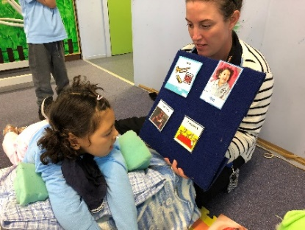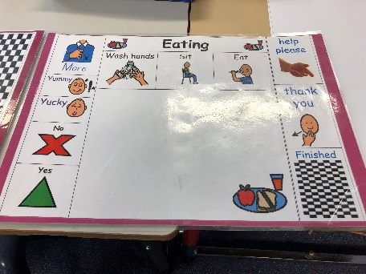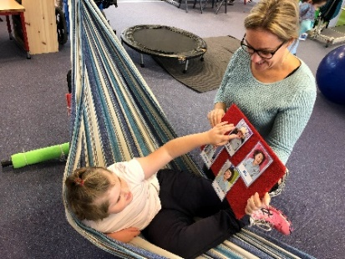
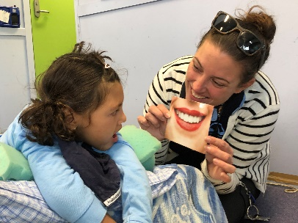
Blue Class in action: communicating during morning circle time.

Volunteers in Yellow Class
Yellow Class students welcomed two volunteers, Rachael and Emily, from Ulladulla High School over the last week into their classroom. The volunteers were completing a PDHPE assignment about pro--social behaviour and their reflections on their time at Budawang School were very positive. Yellow Class students enjoyed greeting the volunteers, practising their turn taking skills and participated in shared fun activities with the assistance of the student volunteers. Emily and Rachael were very impressed by Yellow Class's alternate means of communicating including using visuals, sign and communication devices as well as speaking. Emily and Rachael were also able to support the students by setting a great example in morning circle and providing lots of praise and encouragement when the students moved to desk work. Yellow class students also had fun jumping on the trampoline with Emily and Rachael.
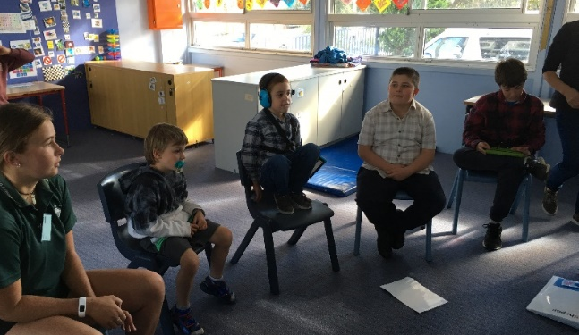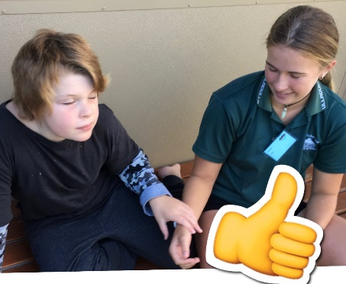

School Camp Preparation
School Camp fun will be happening on the 12th and 13th August (Term 3, Week 4). Senior students will be attending and permission notes will be sent home early Term 3. As per last year parents will need to log their child’s details via a web site, these details for logging on will appear in the next newsletter.

Swimming and Athletics Carnivals
Students, staff and families get your best sporting spirits going because Budawang school will be having a swimming and athletics carnival this year. Staff sport organisers are beginning to plan these carnivals where safety is paramount and lots of fun is being arranged for the students. Parents will be encouraged to assist with the general running’s on the day, notes will be sent home to see if you are able to assist at all on the day. Confirmed dates for each carnival will be announced soon.
Student Awards
Blue Class
Zahra – For arriving at school happy with warm greetings for the staff and working hard throughout the day.
Frankie – For being first to sit and wait for popcorn making and being involved in the whole lesson.
Purple Class
Olivia – For following her morning routine quickly and calmly.
Ryan – For beginning to use picture cards for requesting things.
Yellow
Dylan – For bravery at the doctors last Friday and using his liberator to request different food.
Noah – For great artwork.
Green Class
Lilly – For her excellent organisation skills in the kitchen.
Lashawn – For listening and joining in with the groupl.
Red Class
Archie – For excellent creative writing during dreamtime literacy sessions.
Chris – For being a good friend to Rocky and playing music when Rocky was sad.
RFF Col Award
Daniel – For cooperation and excellent sharing.
Shaylee – For fantastic following of instructions and excellent participation in swimming.

Calendar
3 June | P&C Meeting 1:30pm school library
W10 term 2 | NAIDOC week @ Budawang
12-13 August | Senior Berry Camp

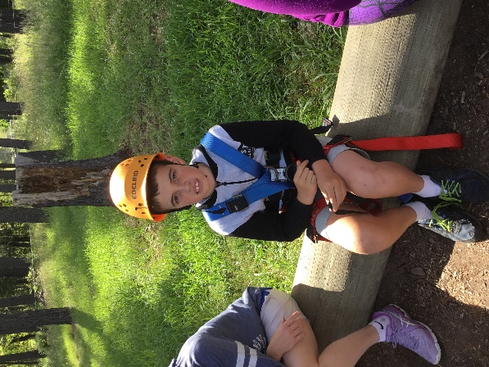

COMMUNITY NEWS
The following articles have been submitted for inclusion in our newsletter and are not part of Budawang SSP School curriculum:

Are You A Parent of a Child Aged 2 to 12?
The Parenting and Family Support Centre at the University of Queensland is conducting research into parents’ opinions about parenting and parenting programs. If you have a child between 2 and 12 years, we would love to hear your views on parenting and the services that are available to you as a parent. You will need to complete a short survey. To find out more or to participate please visit https://exp.psy.uq.edu.au/parenting

