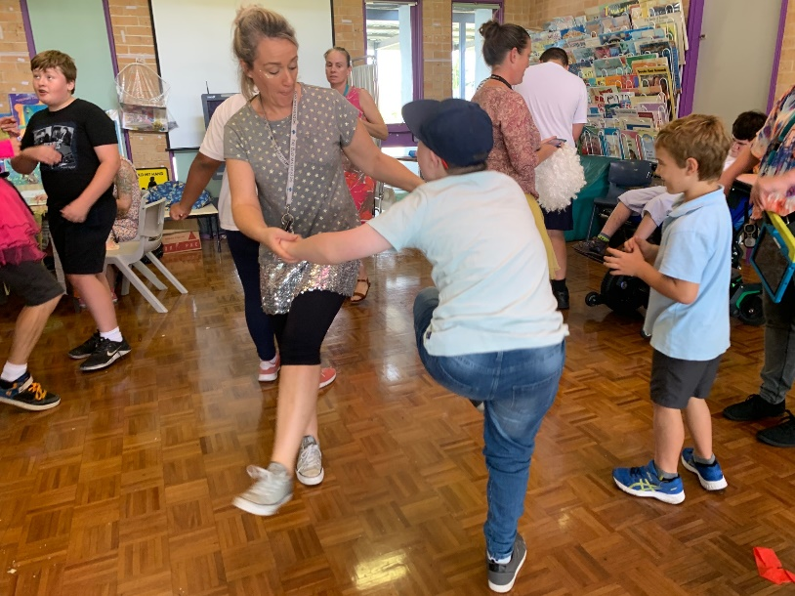
Walk For Austisim
Myrtle Street Pre School will be doing Walk for Autism. If you are interested in donating to a good cause please visit the link. https://www.walkforautism.org.au/fundraisers/childcareeducators. Educators we support children with Autism each and every day in many different ways. This is just another way to show our support for the wider community and those living everyday life with a little extra on their plate.
We've stepped up to walk for autism to help create a world where no-one on the autism spectrum is left behind. We’ll be challenging ourselves to each walk 10,000 steps a day for 8 days while raising much needed funds to support people on the autism spectrum. An estimated 1 in every 70 people is on the spectrum. Along with their family members, this means autism is a part of daily life for over a million Australians. People on the spectrum see, hear, feel and experience the world differently. For many, simply coping with the everyday can lead to confusion, anxiety and isolation. By coming together and taking action, we can help provide opportunities for people on the autism spectrum to participate, engage and thrive in the world around them. Help make our steps count and show your support by donating today!

Disco Day a hit
On Friday 22 March we had our Disco Day! Everyone had so much fun dancing the morning away. We would like to thank all that were able to come and have a dance and an opportunity to catch up with fellow parents, carers and staff. The food was flowing out of the kitchen, the dancefloor was filled and lots and fun and laughs were had. We even had some of the staff and students raid the dress up box and some of the outfits were outrageous! We love a good dress up and dance here at Budawang and are already looking forward to the next one!

Easter Hat Parade
Our Easter Hat Parade will be on the last day of term Friday 12 April. The parade will be starting at 11:30am in the main playground and we will be providing a BBQ lunch. If you have not returned the note letting us know if you are able to make it and how many people will be attending, please let us know as soon as possible so we can look at how many we will be catering for. Thank you. We are looking forward to seeing the student’s creations this year and catching up with our families.

End of Term 1
With the end of Term 1 coming up next week on Friday 12 April, we would like to wish everyone a happy and safe break with their families. Term 1 has been a fantastic start to the year, all the students have been wonderful with big changes happening this year. We are hoping Term 2 will be bigger and better and are all looking forward to see what the near future has to bring. Term 2 will resume on Monday 29 April. We will be saying see you soon to Elaine, who is taking the rest of the year off to travel with her family. She will be back next year to resume her teaching and Assistant Principal duties. We would like to welcome back Penny. Penny will be taking over Yellow Class for Elaine, and so it will be great to see a familiar face in the school. Simone and Lenny will be taking over Assistant Principal duties and they are very excited to be part of the executive team.

Community news
Please see attached flyer for an Autism Teaching and resource work shop series at the Wollongong University Campus. All are welcome.

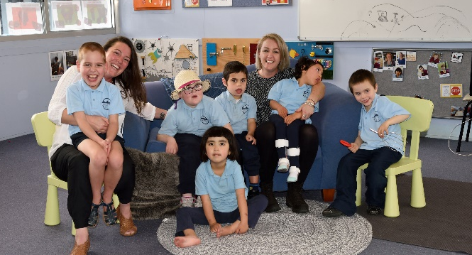
We have had a student from Ulladulla High School participate in an inter-school voluntary program. Angelina Woodhouse, a Year 10 student, has been coming every Friday and working with the students in Blue Class. Angelina has enjoyed her Term at Budawang School immensely and is thinking of coming back for Term 2. Thank you for your hard work and dedication Angelina. We will miss you. Especially Blue Class.

Annual School Report
Our 2018 Annual School Report has been published and uploaded to the School website for all interested to view.

Student Awards
Blue Class
Tommy – For singing his ABC’s.
Mia – For working hard in class to focus during tummy time.
Purple Class
Phoenix – For attempting his desk work independently.
Khy – For working towards communicating with adults in the classroom.
Yellow
Declan – For participating in group times productively using Proloquo2go.
Dylan – For fantastic bike riding skills.
Green Class
Lashawn – For working really hard at his writing skills.
Michael – For his excellent eye gaze work this week.
Red Class
Liam – For being a good sport with changes to his swimming routine this week.
Lachlan – For being responsible in the morning and putting his diary and lunch box away independently.
RFF Col Award
Noah – For attempting positive interaction in the playground enjoying outdoor games.
Luca – For his enthusiasm in all areas of learning.

Calendar
12 April | Last day for Term 1  Easter hat parade morning tea provided
29 April | Students return for Term 2
6 May | P&C AGM 1:30pm school library
15 May | AECG Meeting at Budawang; 6:00 for a light super then meeting.
3 June | P&C Meeting 1:30pm school library
W10 term 2 | NAIDOC week @ Budawang

