`
A week of farewells and welcomes
This week we have seen Ashelia off with a farewell party with her Purple Class friends as she is moving interstate with her family. We will miss Ashelia’s winner smile and wish her all the best in her new home and school. Also this week, Blue Class has welcomed Nathaniel to their class. Nathaniel is a bubbly young man with just the right spirit of fun and adventure for settling in to Budawang School. If you see Nathaniel or his mum while dropping off your child I’m sure they would love you to say Hi.
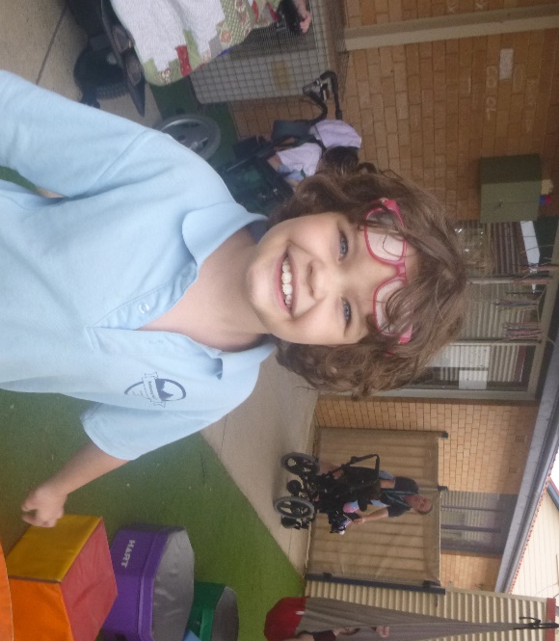

The importance of play
Many of our classes work on skills and learning activities both inside and outside their classroom. The saying that “Play is a child’s work” holds very true at Budawang. Creativity, communication, social skills, following instructions, problem solving and self occupation are just a few of the skill that our students learn while participating in play situations. Blue Class being our youngest class spends a great proportion of their day learning through organised play. These activities are both planned and tailored to the student’s needs. Throughout the activity the student will often dictate the direction of the play, with staff supporting the learning alongside the play. Pictured below is Thomas who loves creating things both big and small. On this occasion, he was assisted to build and use an obstacle course. It’s important to remember that play is not wasted time it is an opportunity for our staff to teach and learn.
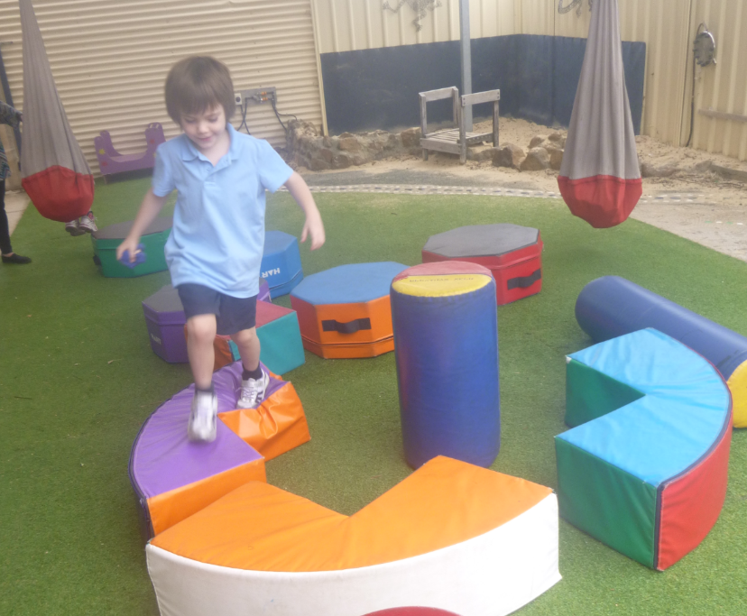

How tall are you?
Yellow Class has been working on long/tall and short. The students had a great time sorting ribbon and drawing around their bodies to see how tall they were. All the children had their bodies drawn around and then they practised writing their names in chalk to label their outlines as well as some students adding facial features and hair.
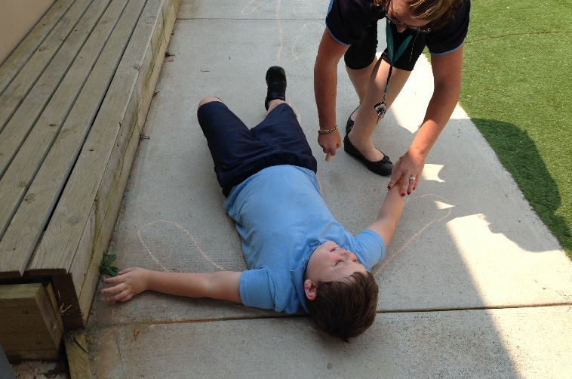

Annette Pham South Coast Woman of the Year
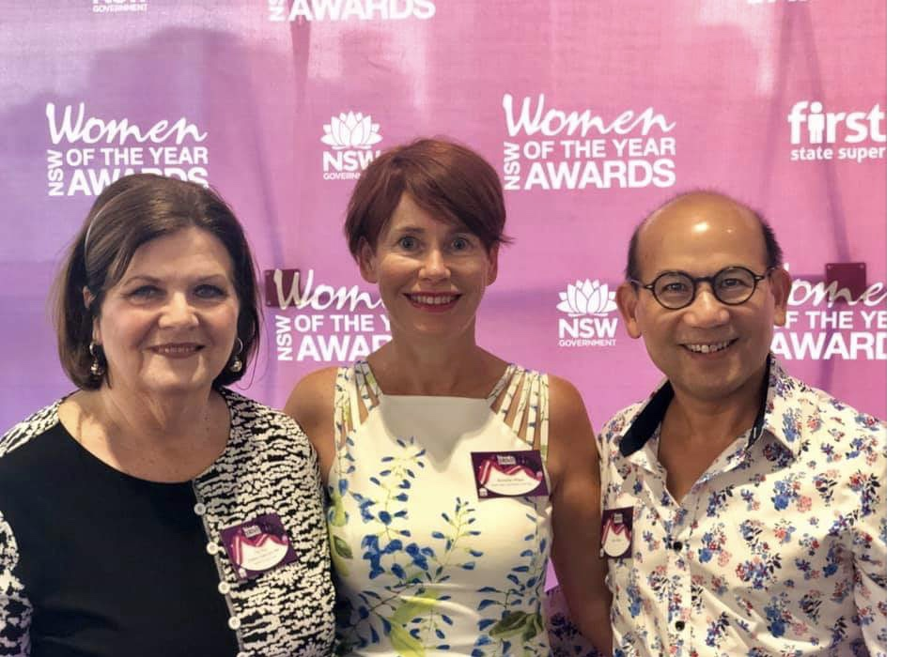
Annette Pham was named South Coast woman of the year at the 2019 NSW Woman of the Year Awards Ceremony at the start of the month. Annette is a disability advocate and is also mum to Liam who is one of our students here. Annette has worked tirelessly to create inclusive environments for people with a disability and for their families. For years Annette has campaigned to have adult change facilities included in the building code of Australia. It will now be part of the code from May 2019. Congratulations Annette, all of us at Budawang are very proud of you and the difference that you make.

Student Awards
Blue Class
Zahra– For arriving at school happy and ready to work.
Nate – For a wonderful transition to Blue Class and Budawang School.
Purple Class
Luca– For working hard on addition in Maths.
Riley – For getting better at following instructions.
Yellow
Tye– For joining in with play activities.
Kohen – For settling in well into Yellow Class.
Green Class
Angela– For her continuous hard work every day.
Genevieve – For her excellent participation during morning circle time.
Red Class
Shaylee– For good listening skills and following instructions during class and play time and for an exceptional swimming lesson.
Rocky – For his excellent work and effort on Eye Gaze.
RFF Col Award
Phoenix– For excellent transition to a two wheeled bicycle.
Ashelia – For excellent contribution in Numeracy lessons.
Calendar
26 March | Purple Day – gold coin donation
1 April | P&C Meeting 1:30pm school library
12 April | Last day for Term 1  Easter hat parade
29 April | First day back for Term 2
6 May | P&C Meeting 1:30pm school library
3 June | P&C Meeting 1:30pm school library
W10 term 2 | NAIDOC week @ Budawang

Community information
NDIS Self-Management
On Thursday 28 March 2019 a meeting will be held by NDIS at 10am-1pm at the Ulladulla Civic Centre. This meeting will be about Self-Management in the NDIS. If you would like to attend please RSVP (02) 42536580 or book on Eventbrite by the following link https://bit.ly/2WUpjGt Come along and find out more about Self-Management and learn the steps to have more choice and control by self-managing your NDIS funding. Hear from people with a disability and carers who are currently self-managing their NDIS plan and how they are doing it. Develop skills and confidence in using the NDIS portal to successfully self-manage your NDIS plan.

