Purple Day at Budawang
On Tuesday 26 March 2019, we will be having Purple Day. Purple Day is a global initiative dedicated to raising Epilepsy awareness. Purple is the internationally recognised colour for Epilepsy. We would like all of the students to wear something purple on the day and bring a gold coin donation to go towards resources for funding and making everyone aware about Epilepsy. We have registered with Epilepsy Action Australia and all money donated will be going to this worthy cause.

School and students back in action
We would like to thank all of our families for coming in this week and meeting classroom teachers. Now that we have all your child’s goals in place we will be able to bring these into the classroom programming. All of our students are starting to settle back into the routine of school. It is great to walk out on the playground and see everyone laughing and having a great time and making new friends. Our class programs are up and running and our community access activities are such as swimming, horse-riding and shopping programs are back up and running. Thank you all for your patience and please remember if there is any questions you have, please don’t hesitate to phone the school or pop in.

Cooking up a storm
The Milton show entries are coming along nicely at the moment. The classes are cooking up a storm making cakes, pancakes, scones and more to enter into next week’s show. The herb garden is producing a nice selection of herbs that will also be entered. If you have time on 1st-2nd March to visit the show don’t forget to have a look for the Budawang entries and see if we have any ribbons.
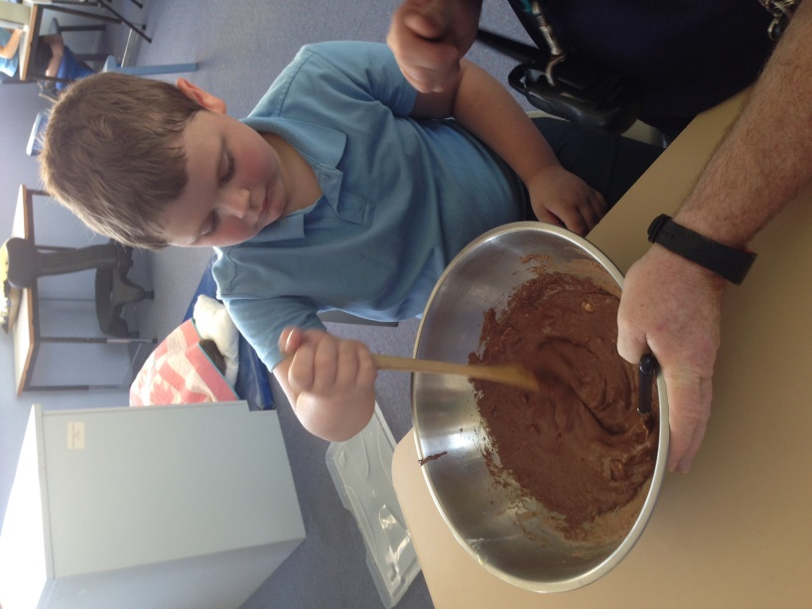

New funding for Budawang School
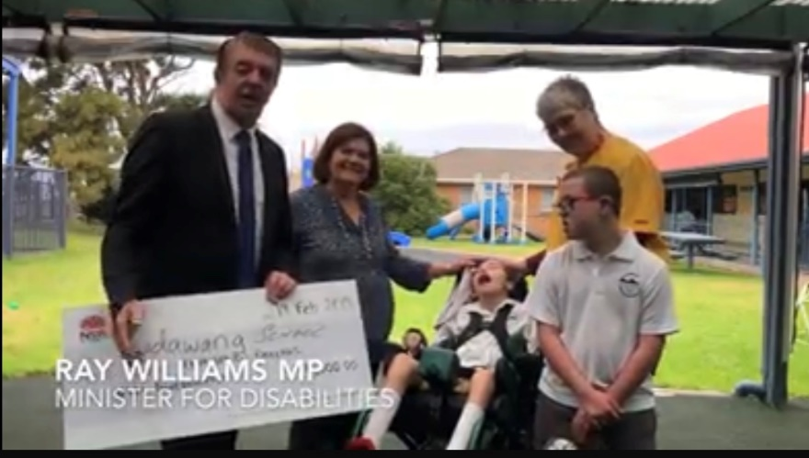
On Tuesday 19 February Budawang had a visit from The Hon. Shelly Hancock and the Minister for Disabilities Ray Williams. Shelly and Ray have secured funding for the amount of $6000.00 for Budawang School to go towards our healthy eating program. Some of this money that has been funded for our school and students will go towards buying new cooking equipment for our student’s kitchen as well as the class cooking programs. Thank you to Shelly Hancock for all the hard work you do for our school.

Student Awards
Blue Class
Ava – For following class routines and participating in class activities.
Thomas – For exploring and using new language to gain his needs and wants.
Purple Class
Khy – For adapting to class room routines.
Ryan – For an excellent start to the school year and working hard
Yellow
Ashton – For working hard at initiating using Proloquo2go.
Zen – For improved enthusiasm when completing deskwork.
Green Class
Genevieve – For great listening skills and beautiful manners.
Flynn – For his excellent desk work skills and drawing expertise.
Red Class
Chris – For his excellent start to the year. Always helping staff and his class mates and coming up with great ideas to organise the class.
Jarrah – For an excellent start to his school year and for his fantastic culinary skills when making pikelets for the Milton Show.
RFF Col Award
Zen – For an enjoyable and engaged swimming lesson.
Thomas – For enthusiastic participation in PE.
Calendar
4 March | P&C Meeting 1:30pm school library
26 March | Purple Day – gold coin donation
1 April | P&C Meeting 1:30pm school library
12 April | Last day for Term 1
29 April | First day back for Term 2
6 May | P&C Meeting 1:30pm school library
3 June | P&C Meeting 1:30pm school library

Community Messages
We have been asked by the following community group to pass on information that may be of interest to you as a family. Please contact them directly if you would like further information.

Horse riding through NDIS
Milea Woods at Trusty Steed Academy is offering horse riding lessons through NDIS. Equine assisted horse riding offers people the ability to feel connected, focused and for them to benefit from movement, which helps to improve general muscle tone whilst riding. Often people experience raised levels of confidence, energy and enthusiasm providing the perfect opportunity for them to connect within their social environment. If this sounds like something your family would be interested in, please phone Milea Woods from Trusty Steed Academy on 0448 655 873.

