Welcome back for 2019
Most students seem to have settled into their new classes well. The teachers and support staff are getting to know what each student likes and doesn’t like. Each of our student have very different needs in terms of their communication and behaviour management and although we have a system for handing over students from one teacher to the next there is still learning to be done in order to be most effective with each student until we get to know them. Our Learning and Support Plan meetings will take place in week 4 and this is a great opportunity to talk in depth to your child’s teacher. We welcome any feedback or suggestions from you that may make your child’s day at school easier or more productive. This feedback could be through your child’s diary or you could arrange a meeting time with your child’s teacher through the office.

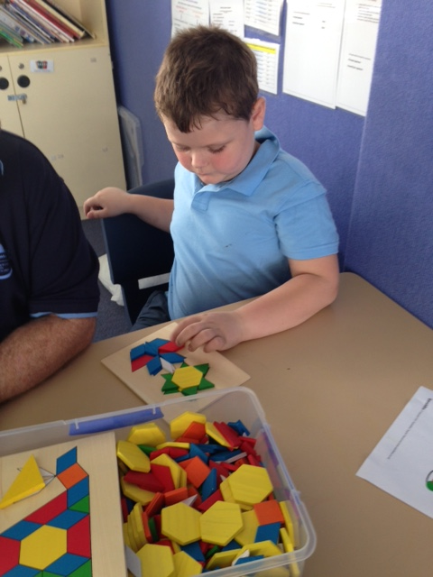

New Staff
We would also like to welcome a few new staff members. A couple of these you may have seen at Budawang previously as they have done some casual work here in the past however, one of our teachers in now to our school. Shannon is the SLSO on the Purple Class. Shannon has done some work in various classes throughout 2018 and is a welcome addition to our SLSO team. Lynette has also done lots of casual work in our school including 3 days a week for a whole term last year. She has lots of special education experience both in Australia and overseas and has settled will into the role of the Red Class teacher. We welcome Kim to the role of Purple Class teacher. Kim comes to us with experience teaching students with moderate to severe intellectual disabilities and autism both in mainstream classes and support class. Kim has confidently taken the reins in Purple Class and quickly getting to know the student both In her own class and throughout the school. We look forward to using the experience and expertise that these staff bring to our School.

School start and finish times
A reminder to all of our families and for our new families that the opening time for school is 8:55am and finish time is 3:00pm. Lessons begin at 9:25. There may be staff at school in the morning and afternoons but our staff use this time to have meetings, prepare lessons, activities, classrooms and visual supports for the students in their class. As such, there is no teacher or learning support officer rostered on duty until 8:55am. Please keep this in mind at drop off and pick up times. We appreciate your efforts to stick to the following times.

Canteen Wednesday
Just a reminder to all of our students and families. Canteen is back and will be starting up on Wednesday 13 February. Ulladulla Public School Canteen has been kind enough to offer their services again to us this year. If your child would like to order their lunch, please place your order and your money in a lunch bag with your child’s name and school written clearly on the front, a note in the communication book will help you child’s teacher find the order if it has slipped to the bottom of their bag. The lunch orders will be collected at 9:25 and taken down to the Ulladulla Public School Canteen and will be picked up just before lunch. Canteen will only be on Wednesday. Please see attached for the list of goodies available for you child.

AAC Training
On Thursday 31 January we had a Speech Therapist and Occupational Therapist from the Northcott Society to provide specialist training in Augmentative and Alternative Communication (AAC) and the use of the Eye Gaze equipment and some intensive training for the staff. All of our staff have benefitted greatly from this training. Many of our staff members have a reasonable understanding of some of the different types of AAC but it was great to add the eyegaze technology to the list of things we now feel more knowledgeable about. We would like to thank the Therapists from Northcott for coming along and providing invaluable training to our staff, parents and volunteers. We understand that it would have been a tough week for our students having their week interrupted and for parents to organise having their child home on what would have been a school day. We cannot thank you all enough for support our staff to undertake this specialist training that will benefit all of our students.
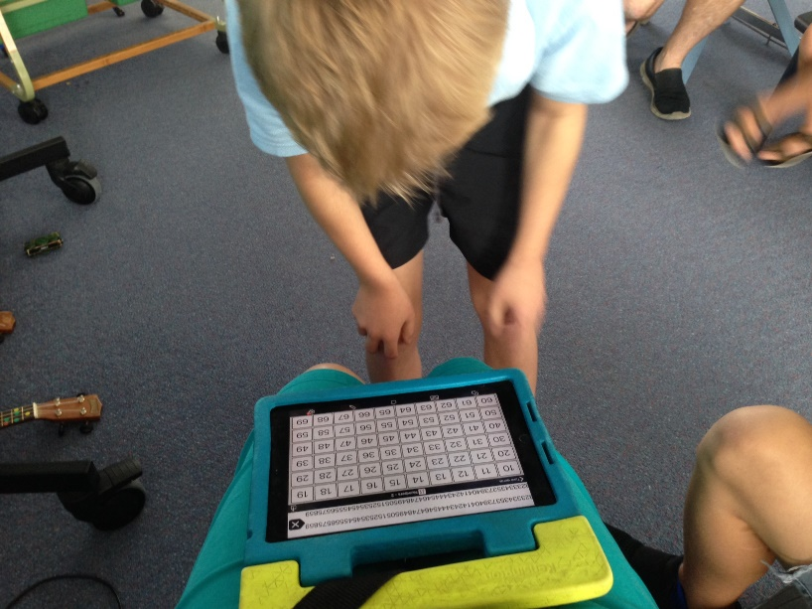

Student Awards
Blue Class
Kohen – For a fantastic start to the year in Blue Class.
Purple Class
Ashelia – For helping her classmates.
Yellow
Dylan – For an excellent start to the new school year.
Green Class
Daniel – For his excellent transition skills to a new class and following instructions.
Red Class
Shaylee – For excellent independent work and having a great start in Red Class.
RFF Col Award
Noah – Excellent bike riding performance and compliance.

Calendar
13 Feb | Lunch order Wednesday
4 March | P&C Meeting 1:30pm school library
1 April | P&C Meeting 1:30pm school library
12 April | Last day for Term 1
29 April | First day back for Term 2
6 May | P&C Meeting 1:30pm school library
3 June | P&C Meeting 1:30pm school library

