Semester two reports
School reports will be due soon with the end of the semester coming close. If you could please bring back to school the folder that your child received with their semester one reports so we can place the new school report in, that would be wonderful.

Augmentative & Alternative Communication training
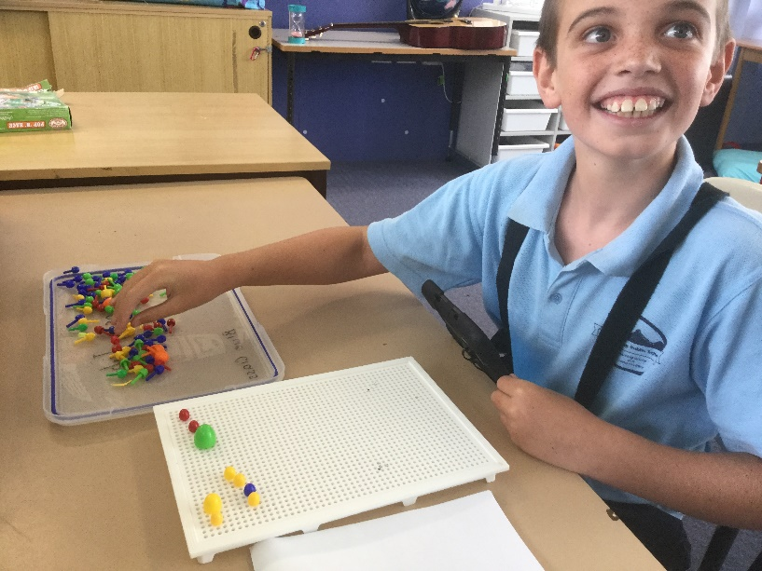
A note has been sent home, emails sent and notifications on facebook and the website, about proposed changes for our Augmentative & Alternative Communication training in Term One 2019. It has been bought to our attention that we are unable to alter our staff development day 29 January 2019. Therefore on Tuesday 29 January 2019, students will stay at home and staff will have a normal staff development day. Students will resume school on Wednesday 30 January. Thursday 31st January will be the training for Augmentative & Alternative Communication students will stay at home for this. From then onwards everything will be back to normal. In term two after the school holidays, staff and students will return to school on Monday 29 April. We do appreciate that the first week back will be disrupted and perhaps confusing for students but the benefits of this training for all students will outweigh the hassle. Thank you to everyone for supporting this initiative.
Assistive Technology training session
Penny Greenwood one of the teachers, will be conducting a training session on the Wednesday 5th. It is for all interested staff, volunteers and parents. It will be held in the Red Classroom at Budawang School at 8am in the morning. The session will run for an hour and will be touching on many aspects of assistive technology. If you are interested in coming along, please contact the school or Penny.
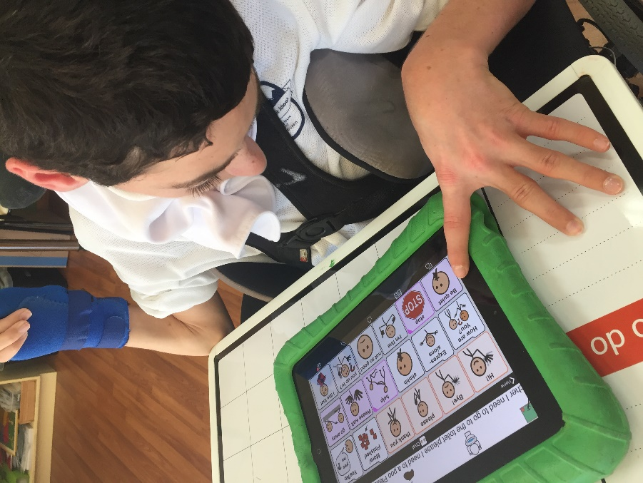
Green Class supports Jindalara
This year Green Class have mastered the art of cooking and have been doing “Lunch Order Thursdays”. Every Thursday Green Class will cook staff and students a delicious meal, each meal cost $3. This is part of their Life Skills program which includes shopping, preparing and cooking meals, cleaning and delivering the meals to the staff and students. They have saved the money that they have raised and decided that they would donate the money to Jindalara Respite Cottage. Jindalara were very thankful to be chosen by our students and last Friday at assembly, the students presented a member of the Jindalara Committee with a cheque from Green Class.
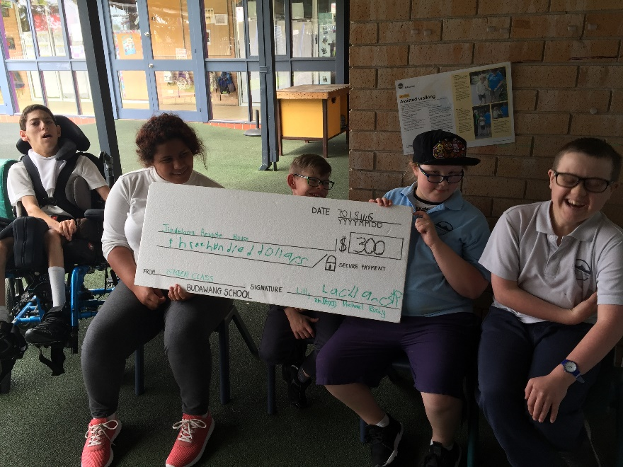

New Canteen menu for lunch order Tuesdays
A note was sent home at the end of the week last week and on our Facebook page as well with the new summer menu for the Ulladulla Public School Canteen for our Budawang lunch order Tuesdays. If you did not receive one, please let us know and we can send one home. A big thank you to the Ulladulla Public School and the Canteen for letting our students share these delicious foods once a week.

School drop off time
A reminder that school drop off time is at 8:55am. Staff are not on duty until this time. Please keep this in mind when dropping off your child. If you need to drop off your child earlier due to unforeseen circumstances, please come in or phone the Principal Karen to organise.

Student Awards
Blue Class
Zen – For building confidence in his communication to express his needs and wants. He is learning to use phrases to request items and activities.
Zahra – For welcoming and making friends with students in our class.
Purple Class
Noah – For actively and engagingly drawing 14+ animals and communicating as to what he drew via animal sound or attempting to say the animal name.
Grace – For a great transitioning experience to Ulladulla Public School last week.
Yellow Class
Chris – For taking excellent care when doing his deskwork.
Daniel – For being a great friend.
Green Class
Lachlan – For being an excellent helper at making lunch orders.
Chase – For being great at managing his feelings.
Red Class
Kelley – For trying hard to overcome obstacles in life and doing so well. We are all very proud of you.
Liam – For outstanding

Calendar
4 Dec | P&C 1:30 Library: all welcome.  Tuesday of the month
5 Dec | Assistive Technology training session 8am Budawang School
10 Dec | School Presentation Day 1:30-3:00
12 Dec | Year 12 Graduation
19th Dec | Last day of school for students
20th & 21st December | The last two days of Term 4 are listed as Staff Development/Pupil Free days. Our staff have undertaken extra training throughout Term 3, equivalent to these two days. Therefore the school will be closed on 20th - 21st December.
29 Jan 2019 | Staff Development day  Students remain at home
30th Jan 2019 | Students back to school
31 Jan 2019 | Augmentative & Alternative Communication Staff Training- Students remain at home.
Friday 1 Feb | Students at school
12 April  2019 | Last day of school for Term 1
29 April 2019 | Term 2 first day back for staff and students

