Presentation Day 2018
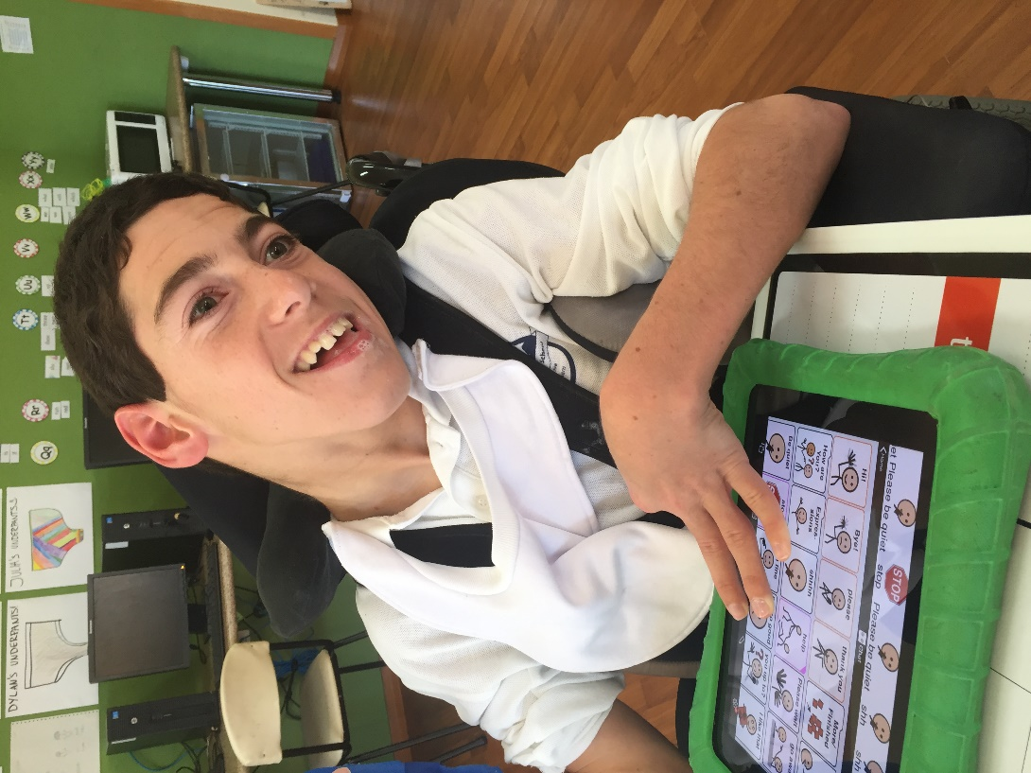
The classes are already preparing their performances for the end of Year Presentation Day assembly. This Year it will be held of Monday the 10th December. This year we will be trialling a new time for Presentation Day. The program will be similar to previous years however we will be beginning at 1:30 and will conclude at 3:00. This will make sure that all students can attend as it is during school hours.

Assisting our students
Are you interested in spending some time at Budawang School to assist our students develop their literacy and numeracy skills? Would you enjoy spending an hour each week helping them to learn to swim, bike ride or walk? Could you spare some time to help with artwork or cooking, shopping or music? Our students all have a severe or moderate intellectual disability, so if you would like to learn more about how you can help them learn, please phone the school and speak with one of our friendly office staff on 44551491. We will provide training.

Special Swimming Scheme
Blue and Purple Class have now completed their Special Swimming Scheme. It is great to see the confidence and skills of the youngest members of our school grow with the repetition of swimming each day for a week. We would like to thank the parents and volunteers who helped out to ensure that we had enough swim helpers for each child.

Fantastic Staff Development Opportunity
In term one 2019 Budawang School has been offered a wonderful training opportunity. The training is in Augmentative and Alternative Communication (AAC) and the use of the eye gaze equipment, with some intensive training on programming with an eye gaze device. There will be a Speech Pathologist and an Occupational Therapist on site to help train our staff. The Northcott trainers are unable to attend on Tuesday 29th January which would usually be our staff development day, so our staff are seeking the support of the parents to move the staff development day from the Tuesday, to the Thursday of the first week back at school. This proposal has been endorsed by the School P&C. If you are in support of this or have any further questions, please phone the school and have a talk with Karen. If we don’t hear back from you by 4 we will begin the formal Departmental paperwork on Wednesday week 4.

Successful grant from Veolia Mulwaree Trust
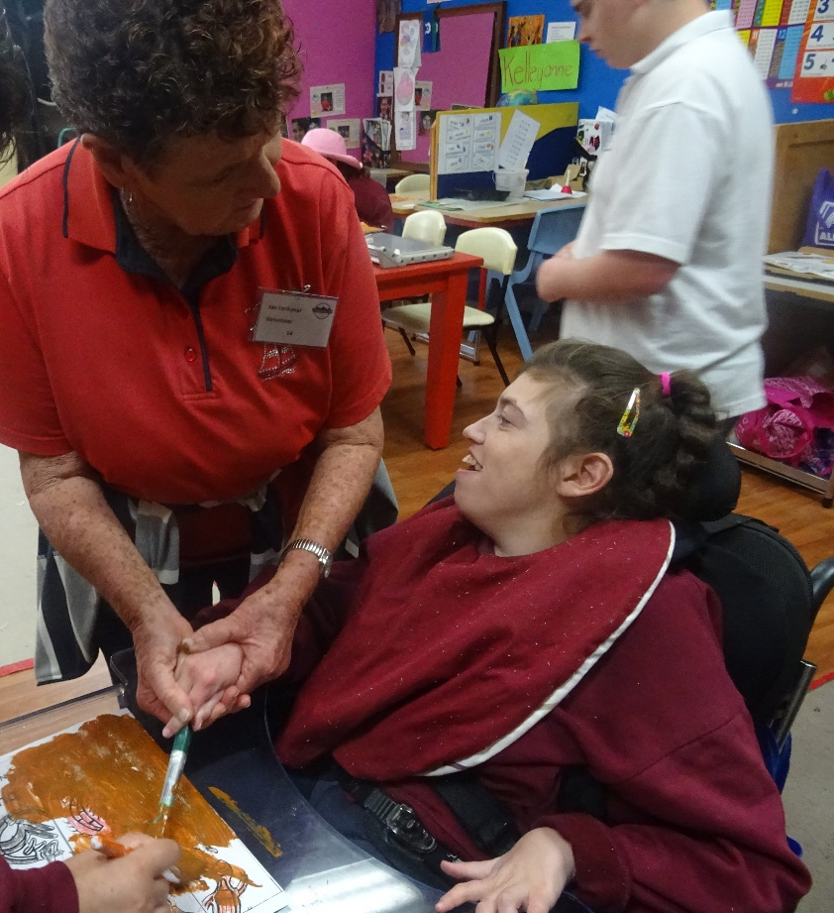
Late last term the P&C, led by Annette Pham, applied for a grant through Veolia Mulwaree Trust to help our purchase an Eyegaze computer and software for the students at our school who are unable to access other kinds of technology. We are thrilled to let you know that the grant has been successful and we are now in the process of ordering the device. Thank you to Veolia Mulwaree Trust to giving our school such a generous grant. The device and software is very expensive and without the grant of over $12000 would not be possible for us to purchase. Thankyou also to the P and C who are putting in some money for this device. We will be sure to give you updates as this equipment arrives at our school and begins to be incorporated into our teaching and learning programs for the targeted students.

Student Awards
Blue Class
Ava – For joining in on group activities in Blue Class and for wonderful turn taking.
Mia – For making new friends at school.
Purple Class
Noah – For sitting and waiting patiently after recess and lunch to go to class and for using PEC’s to communicate in class.
Lashawn – For great participation in class activities.
Yellow Class
Flynn – For independent work when required.
Declan – For fantastic participation in group time.

Green Class
Shaylee – For excellent participation in literacy activities.
Dylan – For wonderful use of his new liberator communication device.
Red Class
Genevieve – For being a calm, cooperative self-starter this term.
Angela – For excellent participation in the community, great community sport involvement.

Calendar
8-9 Nov | School Camp
10 Dec | School Presentation Day 1:30-3:00
12 Dec | Year 12 Graduation
19th Dec | Last day of school for 2018
20th & 21st December | The last two days of Term 4 are listed as Staff Development/Pupil Free days. Our staff have undertaken extra training throughout Term 3, equivalent to these two days. Therefore the school will be closed on 20th - 21st December.
29 Jan 2019 | First day back at school
31 Jan 2019 | Augmentative & Alternative Communication Staff Training

Anglican School Site Consultation
The consultation process to determine the use of the site by the Department of Education has commenced. Belinda Dixon (our P&C President) and I went to the initial meeting and site tour last Wednesday.
We have been given a roadmap for the process and decision making criteria. The next consultation meeting will involve a small group from each school, taking back ideas and priorities so that a collaborative approach can be taken toward the final submission.
I am looking forward to getting together with our school community over the next couple of weeks to gather your ideas; we are looking to develop a strong educational rationale for the site, focusing on the synergies that can come from the effective sharing of the site.
Dates for get together will follow but do call any time to discuss ideas and suggestions you may have.

