Last Week of Term 3
It has been a busy term at school with lots of illnesses amongst students and staff. We are hoping that the holidays will be a time where everyone can rest and recover and that we all come back healthier for Term 4. We would like to remind you that in Term 4 there is no staff development day at the beginning of the term as with other terms. School will resume on Monday the 15th October with students and staff starting back on the same day. We hope you have a happy and safe holiday and look forward to seeing all the students back after the 2 week break.

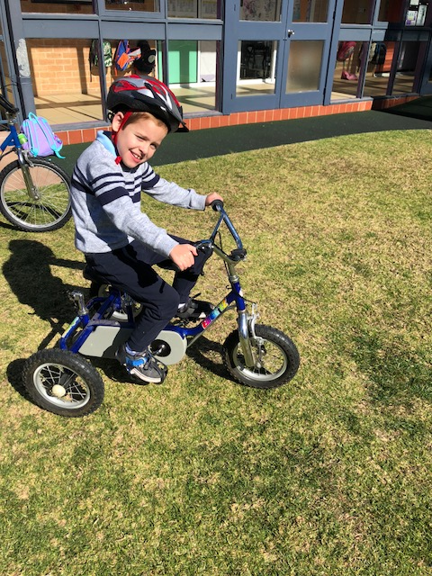

Up and Coming Events for Term 4
Intensive swimming. The program will run in Week 2 and 3. This year Purple and Blue Classes will swim for one week each. This means swimming every afternoon for the week. Students in these classes should be bringing home notes before the end of Term. Please return these ASAP.
School Camp. 8th and 9th November. This will be held at Berry Sport and Recreation Camp as it has been in other years. Students who are in Yr5-12 should have received a note home some time ago and we have received a few back already. Your child will bring home a reminder note soon that should be returned ASAP. If your child is not going to camp and you haven’t already let us know please phone the office so we can make arrangements for them to remain at school. Please note that there is a school permission note as well as online registration.
Presentation Day. This year presentation day will be held on Monday the 10th December. We look forward to seeing lots of families there so please save the date.

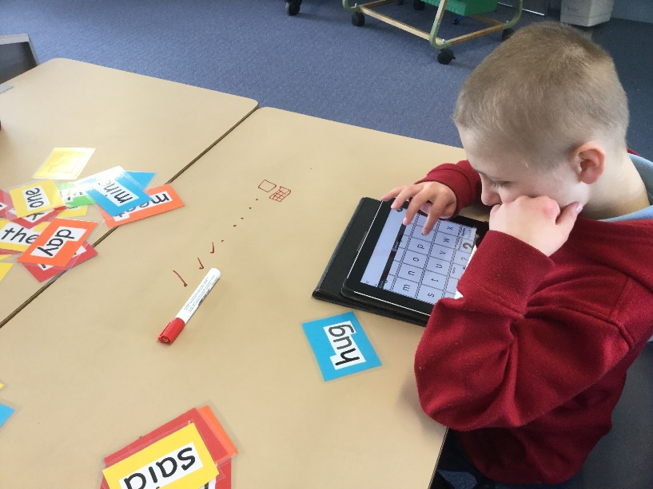

Sun Safety at School
With the warmer months upon us we will begin to focus on students wearing hats during playground time. Most children have school hats at school. We understand that for some of our students wearing hats is a very overwhelming and unpleasant sensory experience for them and we will encourage but not push these students to wear hats. If your child has a preference for type of hat or method of putting it on that would be useful for our staff to know please let us know so we can help you child set up good sun safe habits at school. If you are sending in hats from home please ensure that they are not “special” hats as things can get lost or broken at school. Please also ensure that you label your child’s hat so it can be returned to the correct class if found.

School Starting Time
Most people are doing the right thing and dropping their child off to school after 8:55 however there are a few children still at school before this. This is a quick reminder that our teachers and support staff are not on duty in their classrooms until 8:55. They are often at school, in their own time, well before this but are busy preparing lessons and work before the school day begins.

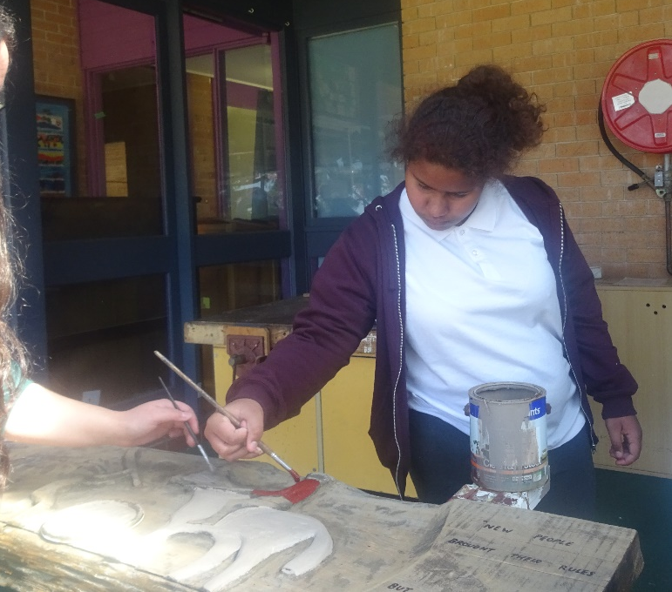

Student Awards
Blue Class
Frankie – Welcome back Frankie after being away unwell.
Zen – For working hard to complete his morning activities.
Purple Class
Grace – For her organisation skills in the morning when she arrives.
Yellow Class
Christopher – For excellent participation in all areas of class.
Tye – For regularly following a 7 step schedule.
Green Class
Michael – For great improvement in communication with staff and students.
Lachlan – Great recognition of notes and coins during Green Class numeracy.

Red Class
Genevieve – for looking for opportunity to show her excellent reading skills.
Jessica – Farewell to a wonderfully happing and engaging student, we will miss you.

Calendar
28th September | Dress Like Myself Day  Last Day of Term 3
15th October | Students back to school.
22 Oct – 2 Nov | Special Swimming Scheme
23 October | P&C meeting 1:30pm
8-9 Nov | School Camp
19th Dec | Last day of school for 2018
20th & 21st December | The last two days of Term 4 are listed as Staff Development/Pupil Free days. Our staff are undertaking extra training throughout Term 3, equivalent to these two days. Therefore the school will be closed on 20th - 21st December.

