Berry Sport and Rec Camp a success
The staff and students who attended Berry Sport and Rec Camp had an absolute blast this year. It was all smiles and excitement as they took off last Thursday morning and as soon as they arrived at camp, the fun began and did not stop. All students participated in all the activities, a special mention for Rocky and Lily who were the only students to get a bullseye in Archery. And also a special mention for Liam, Angela and Michael for their awesome rock climbing skills. There was swimming, walking, singing round the campfire and even damper sticks cooked over the fire filled with golden syrup. We are very proud of all the students who attended for being so well behaved and representing Budawang School with aplomb. A special thanks goes out to our parent helpers Annette, Mary and Jane and our Learning and Support Officers Lizzy, Garry and Shannon who worked really hard to ensure that students who required more assistance to join in did not miss out on any activity.

Ulladulla Joinery & Hardware
Since the early 1990’s the Smith family from Ulladulla Joinery & Hardware have been huge supporters of our wonderful school. They have funded numerous programs for students past and present such as swimming, horse riding, and technology among many others. Every single Christmas they have supported our pupils and school by donating Christmas gifts to all of our Budawang students. To say we are grateful is an understatement. At the end of 2018, Ulladulla Joinery & Hardware are closing their doors. We would like to take this opportunity to say thank you for everything that they have done for our school. The effort put in every year is commendable, and we will be forever thankful. We wish them well on the rest of their journey, and there will always be open doors at Budawang for this wonderful family that has given so much.
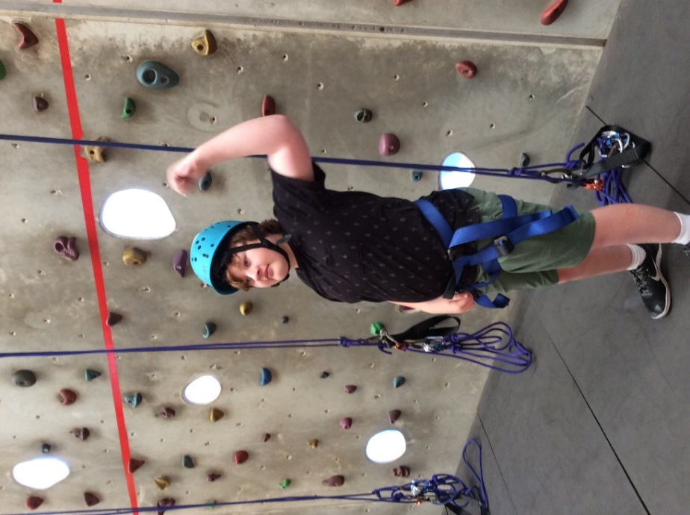
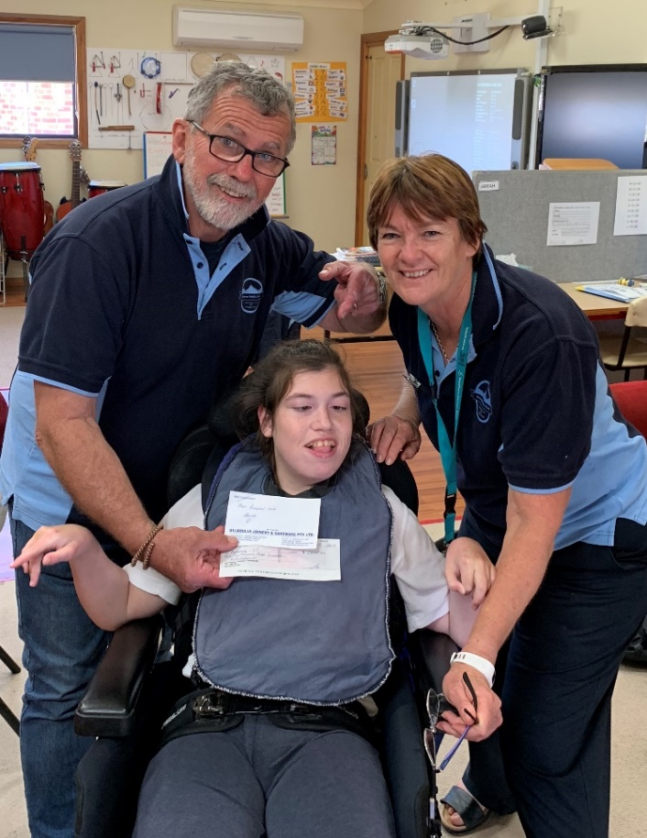
Col and Sylvia with Angela from Red Class with one of the generous donations from Ulladulla Joinery.

Turramurra Rotary Annual Jumbo Flight
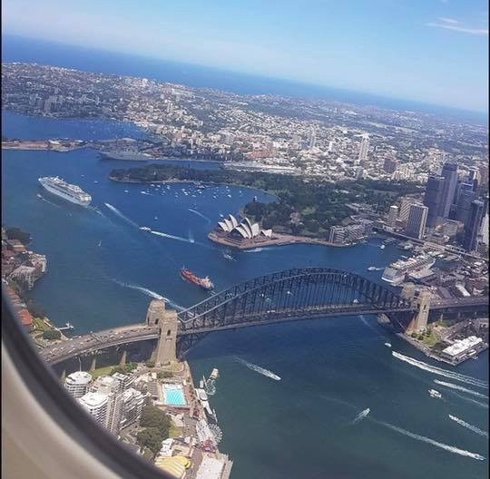
Some of our families from Budawang were lucky enough to experience a 90 minute joyride over Sydney, Newcastle and Wollongong over the weekend. Turramurra Rotary has been organising this wonderful event since the early 1970’s. This event is especially for children who come from underprivileged homes and children with disabilities. For some this is a once in a lifetime opportunity. All the families that attended from Budawang had a wonderful time. Thank you to Turramurra Rotary Club, Qantas for the aircraft and the staff who all volunteered their time Shell Australia for the donation of fuel, Sydney Airport and Annette Pham who co-ordinated our participation. Thanks to Kerrie Shaw, Joanne Bonaccorsi, Kaaren Aldwell and Andrew Ford for sharing their photos with us.

Bella Coastal Properties support Budawang
Bella Coastal Properties have joined up with Budawang School this year, and we will be recipients for the annual Festive Season Giving Tree. The Giving Tree will be up and running from the 1st November and Bella Coastal Properties will be accepting gifts all the way through till Friday 14th December. Anyone can donate to this wonderful cause, and we would like to thank Bella Coastal Properties for being supporters of our wonderful school.

Milton IGA Community Chest
The school P&C have been successful in their application for the annual Milton IGA Community Chest. The Community Chest Funds are gathered by customers that shop at Milton IGA by purchasing a range of products that attract a percentage of its sale to the fund. Once the funds are available, the Milton IGA will donate them to Budawang School at the end of the year. On behalf of all the staff and students at Budawang we would like to thank our amazing P&C for the wonderful work that they do for our school and we would like to the Milton IGA.

Student Awards
Blue Class
Frankie – For making choices and requesting using visuals during eating time.
Purple Class
Luca – For fantastic addition in maths.
Yellow Class
Ashton – For approaching all camp activities with enthusiasm.
Green Class
Lilly – For giving it a go at camp and being a true camper.
Red Class
Jarrah – For a much calmer and compliant attitude around the school.
Calendar
4 Dec | P&C 1:30 Library: all welcome.  1st Tuesday of the month
10 Dec | School Presentation Day 1:30-3:00
12 Dec | Year 12 Graduation
19th Dec | Last day of school for 2018
20th & 21st December | The last two days of Term 4 are listed as Staff Development/Pupil Free days. Our staff have undertaken extra training throughout Term 3, equivalent to these two days. Therefore the school will be closed on 20th - 21st December.
29 Jan 2019 | First day back at school
31 Jan 2019 | Augmentative & Alternative Communication Staff Training- Students remain at home.

