End of the school year
With the end of the school year looming, we would like to take the time to reflect on the year. We have seen so many of our students making leaps and bounds in their education. All of the students that attend Budawang have had a tremendous year, and we are all very proud of each and every one of them and how much they have learnt and grown. We hope all of our families have a safe and happy Christmas break. We hope everyone has a safe New Year and we are looking forward to see what 2019 brings.

Beginning of 2019
A reminder about the changes for the beginning of 2019. As part of our three year plan, we are continuing to develop our capacity in Augmented and Alternative Communication for our students. We are grateful to the school community for supporting the second Staff Development Day, a pupil free day, in week one.
28 January Public Holiday
29 January SDD: students at home
30 January Students’ first day
31 January SDD Training: students at home
1 February Students’ second day:
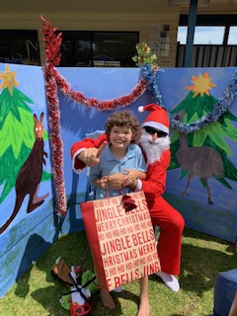
No SDD in term 2.

School Presentation Assembly a hit
On Monday December 10, we had our school Presentation Assembly. We would like to thank all of our students for being so well behaved and all getting up and having a go. Everyone had a lovely afternoon and it was great to be able to mingle and have a chat to the families in a relaxed setting. We would like to thank all the families that were able to make it to school to support our students. We understand that for some it is difficult due to travel and work commitments and we understand that sometimes you cannot just make it and that is ok.
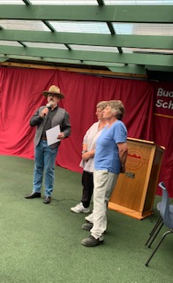

We would like to thank our special guests, The Hon Shelly Hancock, Jen Sherman representing Ann Sudmalis, Chris Pearson from Ulladulla High School and the Smith family from the Ulladulla Joinery. We would also like to mention our wonderful volunteers who help us throughout the year and our amazing staff who work at Budawang School.
Year 12 Graduation
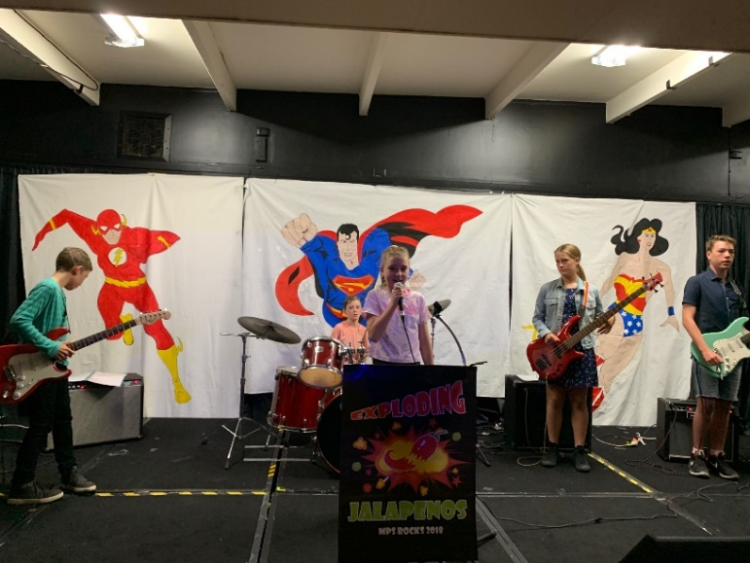
On Wednesday December 12, we had our Year 12 Graduation. The theme was “Super Hero’s” and it was wonderful to see everyone dress up and have a great time farewelling our graduate, Kelleyanne. Kelleyanne has been at Budawang School for a number of years, and as much as it is sad that we will not see her in the playground laughing and having fun, we know that she is entering a new phase of life and we wish her all the happiness in the world in her new adventures. The graduation was a fantastic occasion where all of our Budawang Community got to say goodbye her in style. The rock band from Milton Public School performed for the graduation and were absolutely fantastic. We will miss Kelleyanne and her vivacious attitude to life and we are looking forward to hearing all about it in the future.

Farewell Huey & Ania
We would like to take this opportunity to farewell two of our teachers. Deborah Huish will be retiring after this year. Deb has been teaching at Budawang for many years and has decided that it is time to hang up her hat and see what retirement is all about. She has assured us that she will still be in touch and maybe come do some casual teaching next year so we are sure that we will see her around, but we will miss her and her vibrant sense of humour in the day to day running of Budawang School. Ania Mazurowska will also be leaving us for 12 months, Ania will be doing some travelling and having lots of new adventures, so we will be waiting on some postcards next year from all the places that she will be visiting.
Staffing for 2019
Next year we will be introducing some new staff, Kim Campbell will be joining our team, so if you see her around next year please give her the good old Budawang welcome. Lynette Emery will also be joining us. Lynette has done casual teaching for us this year, so most of you have met her. Congratulations to Kellie S on the permanent position for Special Learning Support Officer. We will also be welcoming Shannon aboard, he also has done some casual work this year and will be joining us on a full time basis for 2019.
Student Awards
Blue Class
Tommy – For great creative expression in his drawing.
Ava – For improved participation in all school activities including music and sitting with the group to eat.
Yellow
Archie – For being enthusiastic in morning circle and all Yellow Class acitvities.
Tye – For making an effort to play with his friends in the playground.
Green Class
Michael – for fantastic use of the Yes/No communication.
Rocky – For using his eye gaze enthusiastically as a means of communication.
Red Class
Liam – For independently engaging with musical activities on Eye Gaze.
Angela – For improved focus on relevant eye gaze areas – Leading to enhanced communication.
Jarrah – For showing his technology skills in numeracy to a school visitor.
Calendar
19th Dec | Last day of school for 2018
20th & 21st December | The last two days of Term 4 are listed as Staff Development/Pupil Free days. Our staff have undertaken extra training throughout Term 3, equivalent to these two days. Therefore the school will be closed on 20th - 21st December.
29 Jan 2019 | First day back at school staff development day
30 Jan 2019 | Students first day back at school
31 Jan 2019 | Augmentative & Alternative Communication Staff Training- Students remain at home.
5 Feb 2019 | P&C meeting 1:30 in the Library

