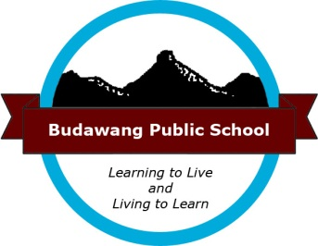
Appendix 29

Volunteers – The Secret Ingredient

Budawang SSP - Every Student Every School

Cleaning the Fish Tank

